**User Documentation**

**Why I chose this project ¿¡**

**Dubai Metro is one of the newest metro systems in the world & is already proving to be one of the lifelines of a truly sprawling commercial city not to mention the glitz and glamour attached to it thus making it a must-see for all tourists. As the Dubai Metro presently covers 47 stations and is slated to be extended even further it is one of the best ways to travel within the city not only for its residents but for tourists as well. The journey commences with buying of a ticket and there are a number of travel cards depending on how much you will travel.**

**One of the main reasons why I chose this project was because I wanted to challenge myself, since I had to learn extra concepts which I have put into use in this project.**

**Another reason, was to help loads of tourist coming to Dubai to plan their journey. This saves their time to figure out the information required for their journey that is cost of each journey, next train’s time, number of stations ,interchange of stations (when required) and Feeder Buses from destination station .It also has a button for Job Applicants which opens a Job Application form. Another feature added to this is Private Access for officials to Add, Rename, Delete, Display & Display Job Applications submitted.**

**How to install Python¿**

* If you don’t already have a copy of Python installed on your computer, you will need to open up your Internet browser and go to the Python download page.

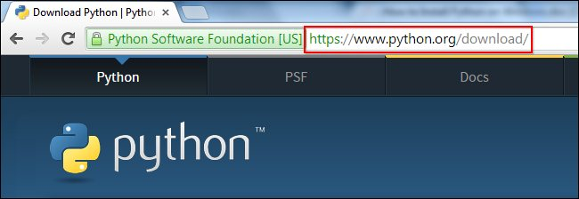

* Now that you are on the download page, select which of the software builds you would like to download. For the purposes of this article we will use the most up to date version available (Python 3.4.1). 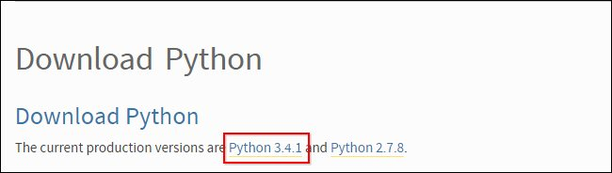
* Once you have clicked on that, you will be taken to a page with a description of all the new updates and features of 3.4.1, however, you can always read that while the download is in process. Scroll to the bottom of the page till you find the “Download” section and click on the link that says “download page.” 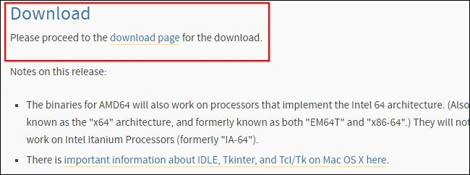
* Now you will scroll all the way to the bottom of the page and find the “Windows x86 MSI installer.” If you want to download the 86-64 bit MSI, feel free to do so. We believe that even if you have a 64-bit operating system installed on your computer, the 86-bit MSI is preferable. We say this because it will still run well and sometimes, with the 64-bit architectures, some of the compiled binaries and Python libraries don’t work well.

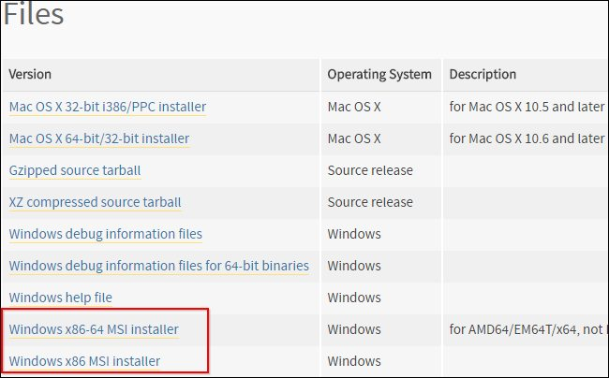

* **Installing Python**

Once you have downloaded the Python MSI, simply navigate to the download location on your computer, double clicking the file and pressing Run when the dialog box pops up.

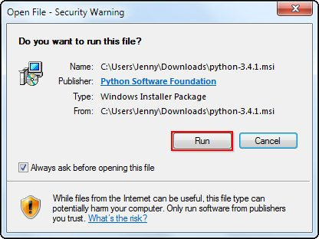

* If you are the only person who uses your computer, simply leave the “Install for all users” option selected. If you have multiple accounts on your PC and don’t want to install it across all accounts, select the “Install just for me” option then press “Next.”

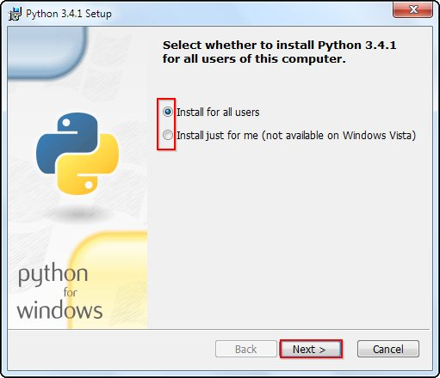

* If you want to change the install location, feel free to do so; however, it is best to leave it as is and simply select next.

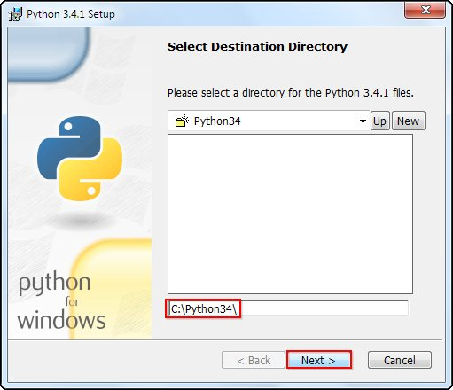

* Scroll down in the window and find the “Add Python.exe to Path” and click on the small red “x.” Choose the “Will be installed on local hard drive” option then press “Next.”

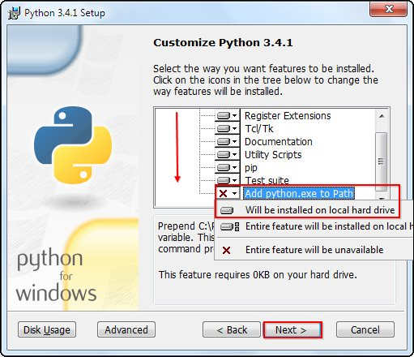

* You will notice that the installation will bring up a command prompt window while Python downloads and installs “Pip.” Pip is just a package management tool. This will allow you to install all the additional Python packages that are available for download through [PyPI (Python Package Index)](https://pypi.python.org/pypi).

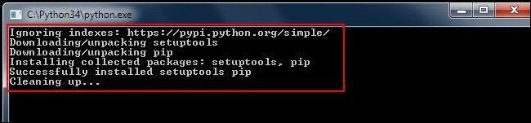

* Now that you have completed the installation process, click on “Finish.”

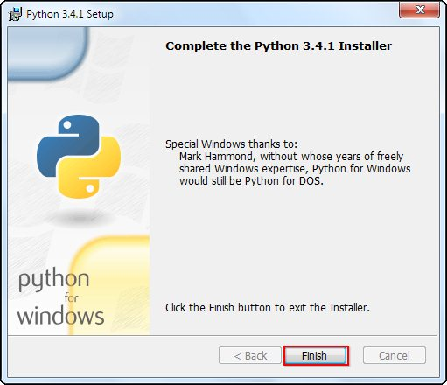

* **Adding Python to System Path Variable**

If you decided to use the Python 3.4.1, you will not need to follow this process. You can simply skip ahead to the next section. The reason is that the new update integrates this process in the installation phase and so you no longer need to manually add the System Path Variable.  If you want to add a second set of variables for Python, you can still follow the procedure but replace “27” with “34.”

* If you chose to use the 2.7.3 version of Python, you will need to follow these steps. Once you have successfully installed Python, it is time to add it to the System Path Variable. Doing this will allow Python to run scripts on your computer without any conflicts of problems.
* Begin by opening the start menu and typing in “environment” and select the option called “Edit the system environment variables.”

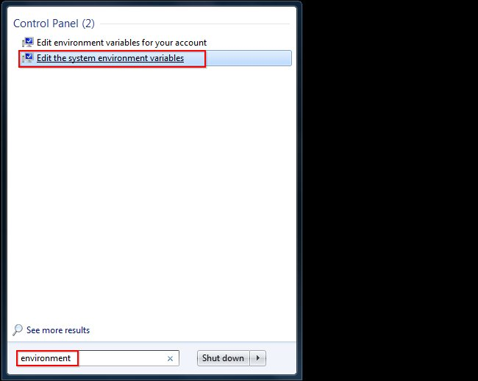

* When the “System Properties” window appears, click on “Environment Variables…”

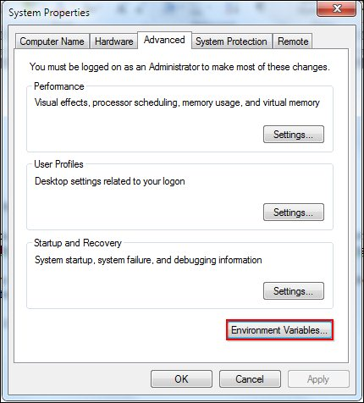

* Once you have the “Environment Variables” window open, direct your focus to the bottom half. You will notice that it controls all the “System Variables” rather than just this associated with your user. Click on “New…” to create a new variable for Python.

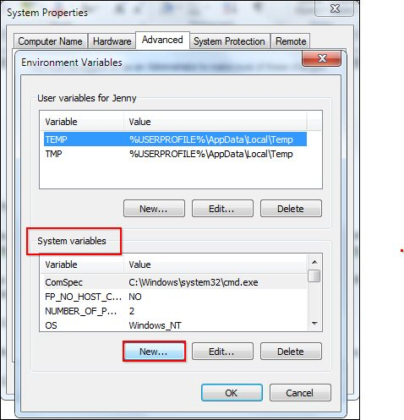

* Simply enter a name for your Path and the code shown below. For the purposes of this example we have installed Python 2.7.3, so we will call the path: “Pythonpath.”
* The string that you will need to enter is: “*C:\Python27\;C:\Python27\Scripts;*”

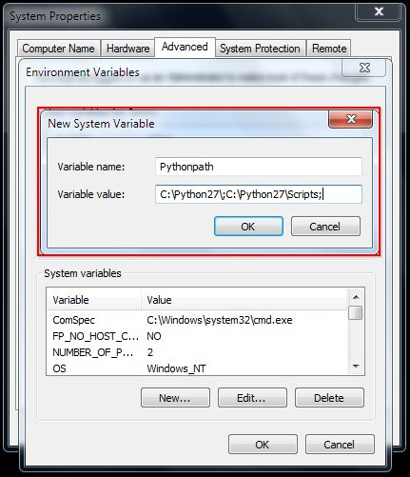

* Press “OK,” then “OK,” then “OK,” then the red “X” to accept all changes and exit the “System Properties” window.
* **Simple Print Directive**

Now that we have successfully completed the installation process and added our “Environment Variable,” you are ready to create your first basic Python script. Let’s begin by opening Python’s GUI by pressing “Start” and typing “Python” and selecting the “IDLE (Python GUI).”

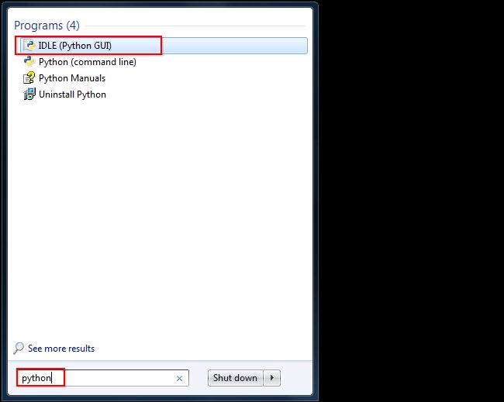

* Once the GUI is open, we will begin by using the simplest directive possible. This is the “print” directive which simply prints whatever you tell it to, into a new line. Start by typing a print directive like the one shown in the image below or copy and paste this text then press “Enter”: print (“Congratulations on executing your first print directive!”)

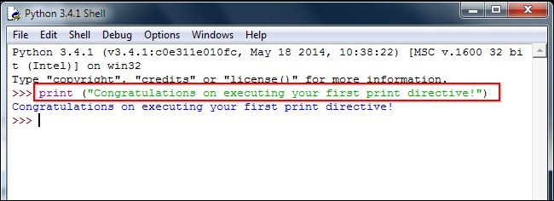

* With Python 3, the interactive mode signaled by the presence of “>>>” means you can do things like simple math without any directives. Try doing a few simple problems as shown in the image below.

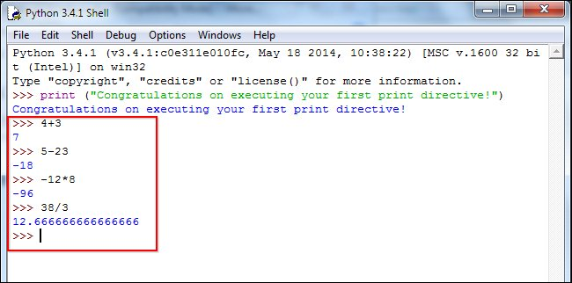

**How to use the program?**

**• Double click on Metro Trip Planner to open the application.**

**• Click on “Continue”**

**• Now you can either choose to check the train timings or you can click on Private Access to continue into editing the official information.**

**• On the main window you also have an option of saving your search if you are a frequent user of metro.**

**• You can also view the list of feeder buses available in your destination station.**

**• Private access option is for the use of officials of the metro for the purpose of changing certain details in the program if necessary.**

**Manual v/s Computer**

**In the present world, we can’t imagine to live without computers, such is our dependence on these electronic equipment’s. Over these years, they have truly evolved not just as an electrical equipment, but our life partners.**

**Regarding travel planner, a computer program is far more efficient. Not only does a travel planner program save a lot of time, but saves a lot of work in gathering information from different places, which can be really frustrating at times.**

**Thus, manual search of information is not only tough, but also is not so smartin the present world.**

**Thus, it is clearly evident that a computer travel planner management program is way more efficient.**

**System Requirements & Installation Manual**

**System Requirements:**

* **Windows(XP or later)/Mac (OS X or later)/Linux/Unix.**
* **Intel 64(AMD64/X86-64 binary) or higher.**
* **1.86 GHz or more.**
* **Minimum 10GB Hard Drive Size (Recommended 150GB).**
* **1 GB free space on hard drive.**
* **2 GB RAM**
* **Graphic Card(Memory Clock Rate – 900-5700 MHz & Bandwidth – 80-230GB/s)**

**Installation Manual:**

* **Double click on the file (DubaiMetro) to start the program.**

**Screenshots**

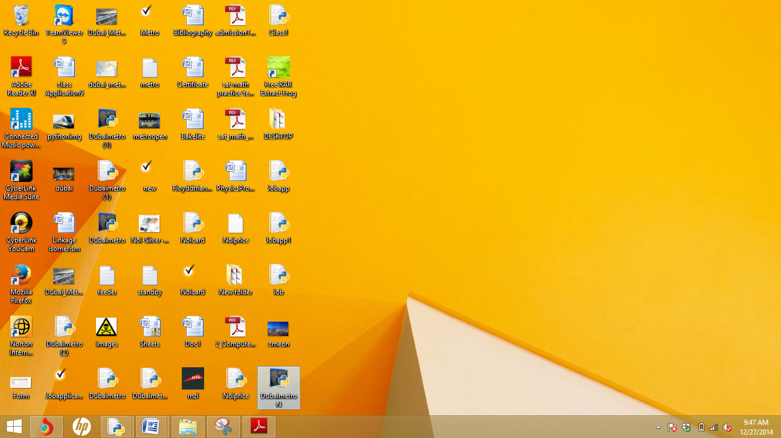

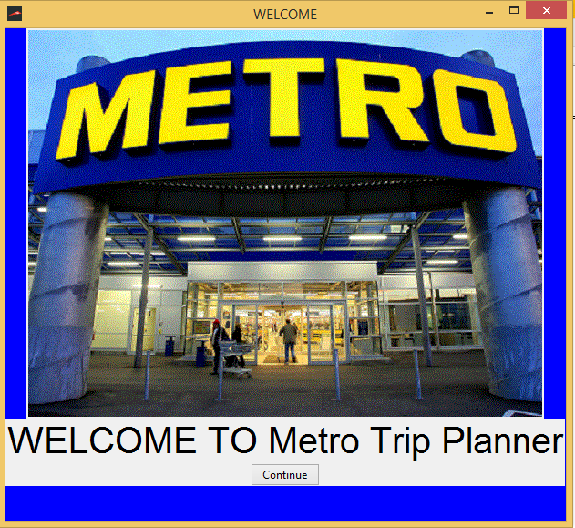

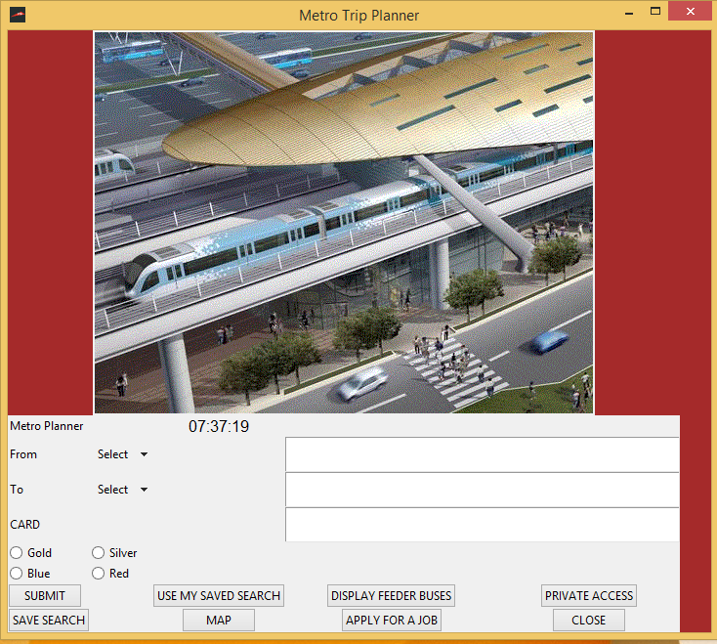

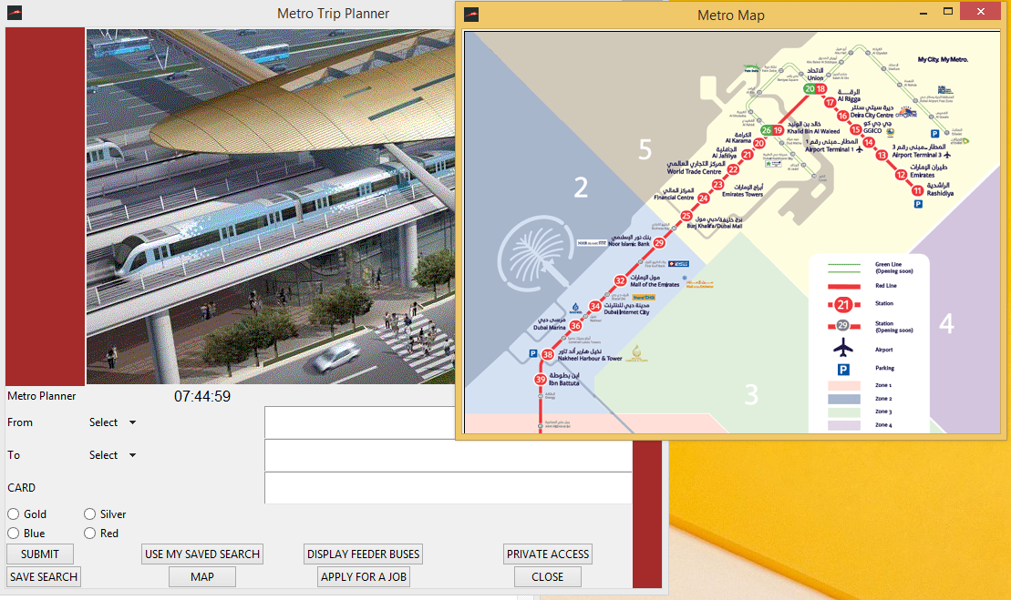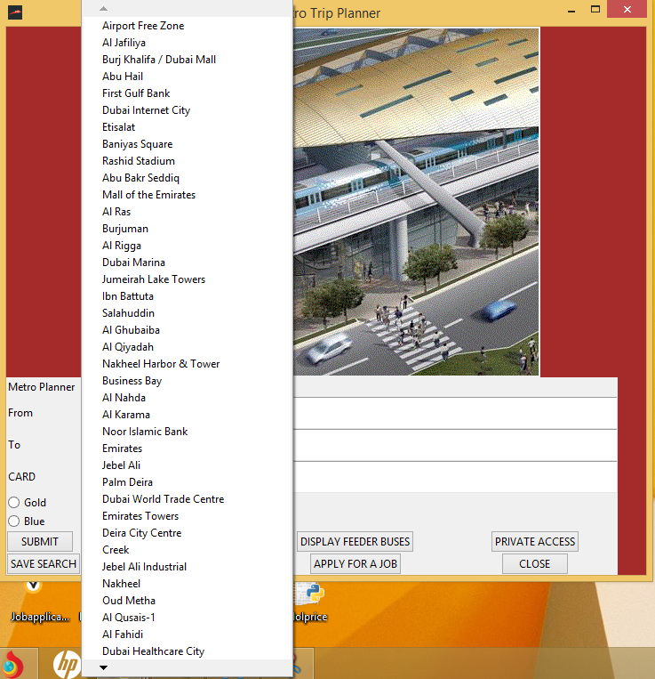

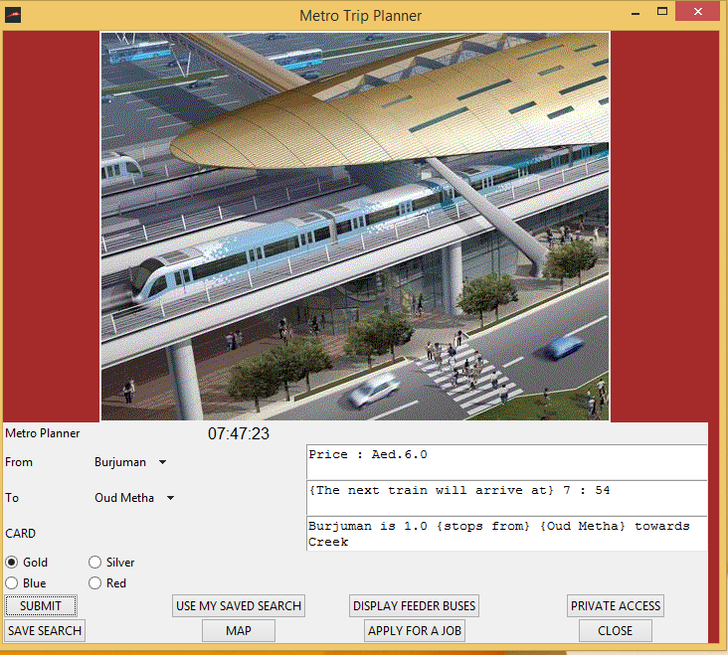

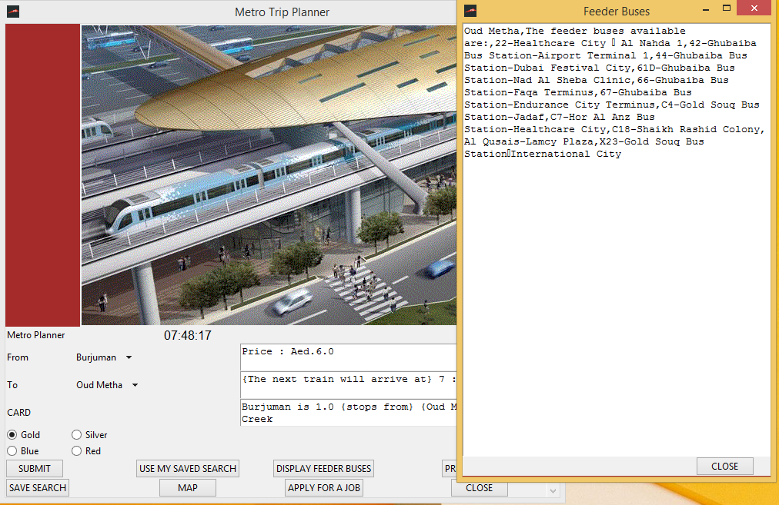

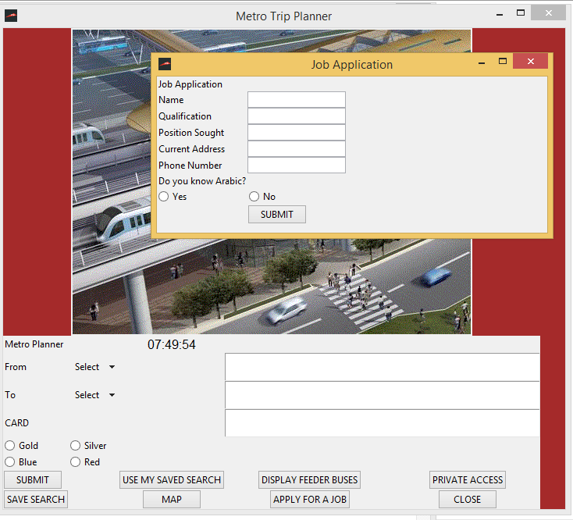

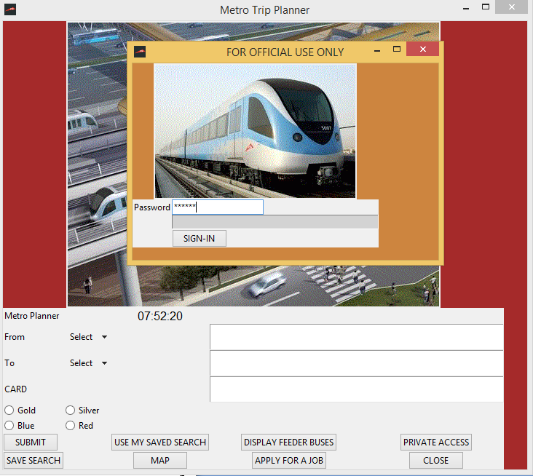

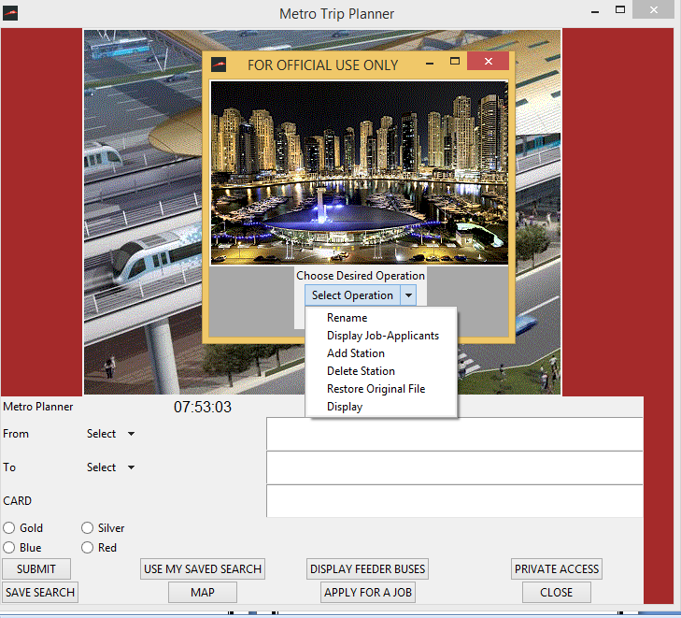

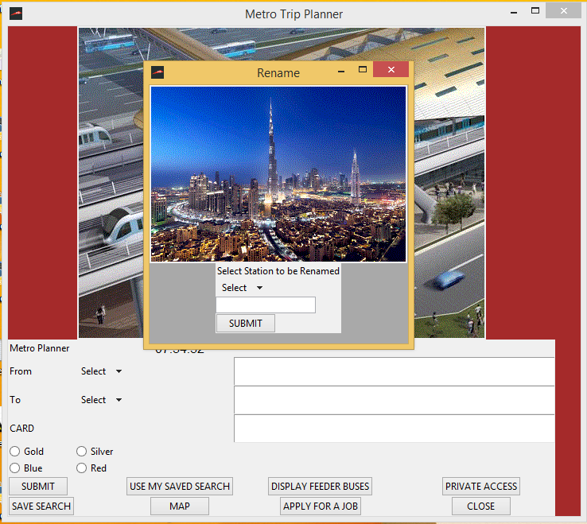

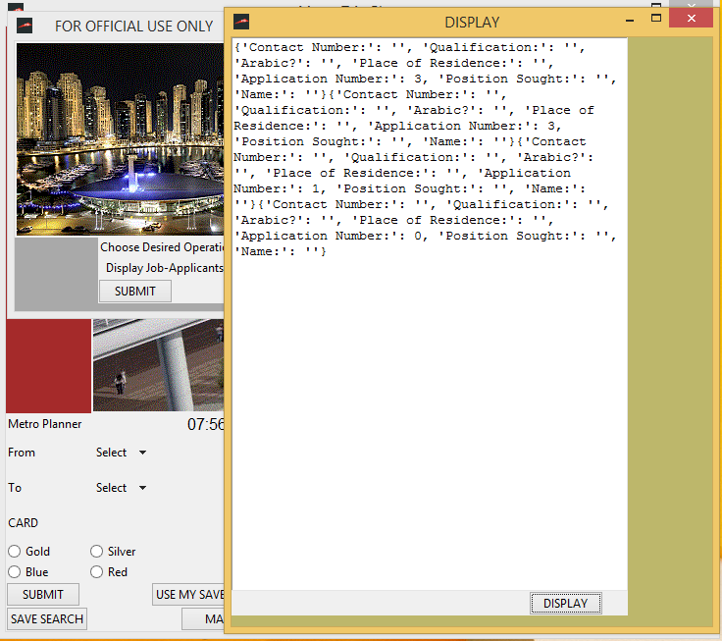

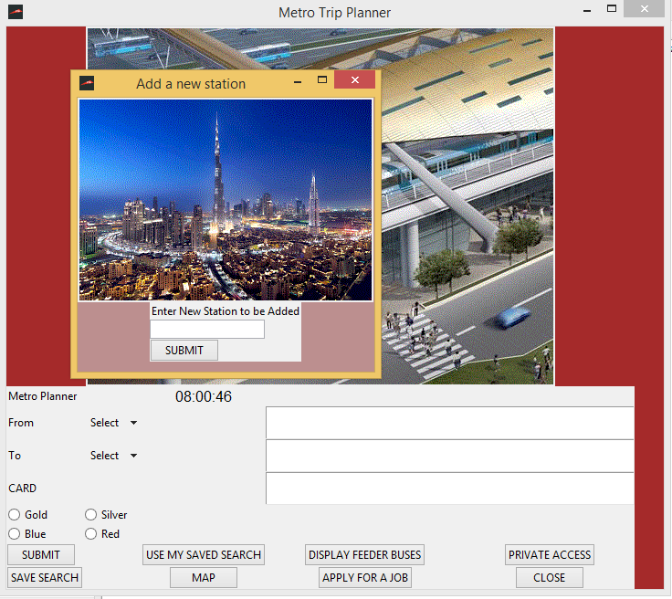

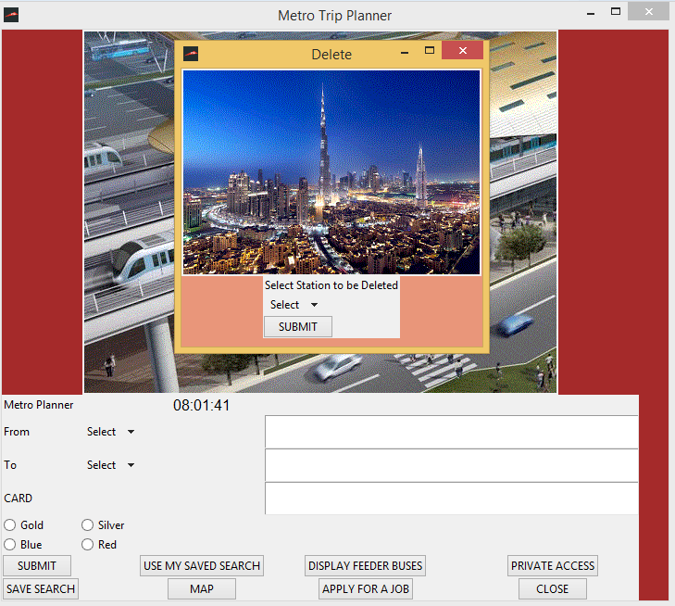

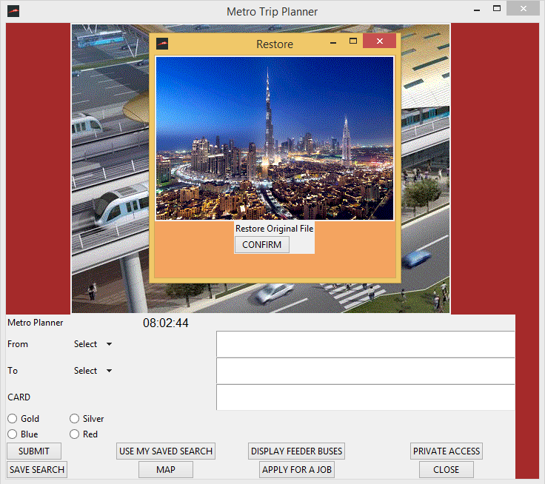

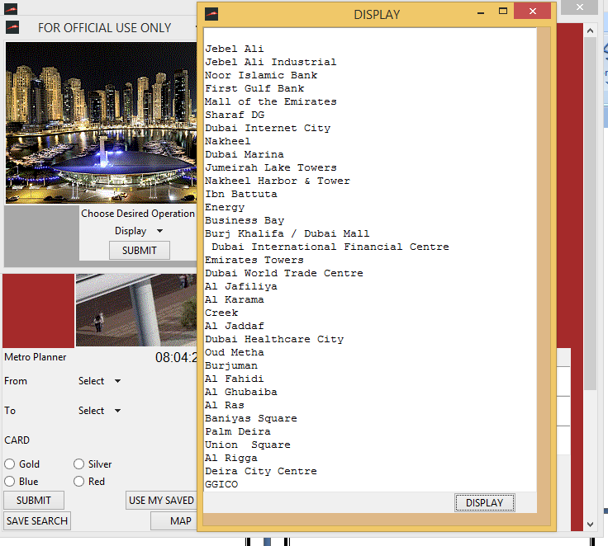

**Technical Documentation**

**Source Code**

**import os**

**import pickle**

**import random**

**from Tkinter import \***

**import Tkinter as ttk**

**from ttk import \***

**from math import \***

**import datetime**

**time=datetime.datetime.now()**

**import time**

**the_time=''**

**class Applicationmain(Frame):**

**def __init__(self,master):**

**Frame.__init__(self,master)**

**self.grid()**

**self.create_widgets()**

**def create_widgets(self):**

**self.welcome=Label(self,text="WELCOME TO Metro Trip Planner",font=('bold',30))**

**self.welcome.grid(row=0,column=0,columnspan=2,sticky=W)**

**self.submit_button=Button(self,text="Continue",command=self.mainprog)**

**self.submit_button.grid(row=4,column=1,sticky=W)**

**def mainprog(self):**

**rootmain.destroy()**

**class Application(Frame):**

**def __init__(self,master):**

**Frame.__init__(self,master)**

**self.grid()**

**self.create_widgets()**

**def create_widgets(self):**

**self.instruction=Label(self,text="Metro Planner")**

**self.instruction.grid(row=0,column=0,columnspan=2,sticky=W)**

**self.ins2=Label(self,text="From")**

**self.ins2.grid(row=1,column=0,columnspan=1,sticky=W)**

**liststations={"Jebel Ali","Jebel Ali Industrial","Noor Islamic Bank","First Gulf Bank",**

**"Mall of the Emirates","Sharaf DG","Dubai Internet City","Nakheel","Dubai Marina","Jumeirah Lake Towers",**

**"Nakheel Harbor & Tower","Ibn Battuta","Energy","Business Bay",**

**"Burj Khalifa / Dubai Mall"," Dubai International Financial Centre ","Emirates Towers","Dubai World Trade Centre ","Al Jafiliya","Al Karama",**

**"Creek","Al Jaddaf","Dubai Healthcare City","Oud Metha","Burjuman","Al Fahidi","Al Ghubaiba","Al Ras",**

**"Baniyas Square","Palm Deira","Union Square","Al Rigga","Deira City Centre","GGICO","Airport Terminal-1","Airport Terminal-3",**

**"Emirates","Rashidiya ","Salahuddin","Abu Bakr Seddiq","Abu Hail",**

**"Al Qiyadah","Rashid Stadium","Al Nahda","Airport Free Zone","Al Qusais-1","Etisalat"}**

**self.var1=StringVar()**

**self.var2=StringVar()**

**self.From=OptionMenu(self,self.var1,*liststations)**

**self.var1.set('Select')**

**self.From.grid(row=1,column=1,sticky=W)**

**self.ins3=Label(self,text="To")**

**self.ins3.grid(row=2,column=0,columnspan=1,sticky=W)**

**self.To=OptionMenu(self,self.var2,*liststations)**

**self.var2.set('Select')**

**self.To.grid(row=2,column=1,columnspan=2,sticky=W)**

**self.ins4=Label(self,text="CARD")**

**self.ins4.grid(row=3,column=0,sticky=W)**

**self.card=StringVar()**

**self.radiobutton1=Radiobutton(self,text="Gold",variable=self.card,value="Gold").grid(row=4,column=0,sticky=W)**

**self.radiobutton2=Radiobutton(self,text="Silver",variable=self.card,value="Silver").grid(row=4,column=1,sticky=W)**

**self.radiobutton3=Radiobutton(self,text="Blue",variable=self.card,value="Blue").grid(row=5,column=0,sticky=W)**

**self.radiobutton4=Radiobutton(self,text="Red",variable=self.card,value="Red").grid(row=5,column=1,sticky=W)**

**self.submit_button=Button(self,text="SUBMIT",command=self.bigprogram)**

**self.submit_button.grid(row=6,column=0,columnspan=2,sticky=W)**

**self.filebutton=Button(self,text="SAVE SEARCH",command=self.fileprog)**

**self.filebutton.grid(row=7,column=0)**

**self.filebutton1=Button(self,text="USE MY SAVED SEARCH",command=self.fileprogram)**

**self.filebutton1.grid(row=6,column=2)**

**self.newgui=Button(self,text="PRIVATE ACCESS",command=self.rta)**

**self.newgui.grid(row=6,column=5)**

**self.newgui1=Button(self,text="MAP",command=self.metromap)**

**self.newgui1.grid(row=7,column=2)**

**self.apply=Button(self,text="APPLY FOR A JOB",command=self.jobapplication)**

**self.apply.grid(row=7,column=4)**

**self.feeder=Button(self,text="DISPLAY FEEDER BUSES",command=self.feeder)**

**self.feeder.grid(row=6,column=4)**

**self.closebutton=Button(self,text="CLOSE",command=root.destroy)**

**self.closebutton.grid(row=7,column=5)**

**self.text=Text(self,width=50,height=2,wrap=WORD)**

**self.text.grid(row=1,column=4,columnspan=2,sticky=W)**

**self.text2=Text(self,width=50,height=2,wrap=WORD)**

**self.text2.grid(row=2,column=4,columnspan=4,sticky=W)**

**self.text3=Text(self,width=50,height=2,wrap=WORD)**

**self.text3.grid(row=3,column=4,columnspan=4,sticky=W)**

**#Create a label that displays time:**

**self.display_time=Label(self, text=the_time)**

**self.display_time.grid(row=0, column=2)**

**def change_value_the_time():**

**global the_time**

**newtime = time.strftime('%H:%M:%S')**

**if newtime != the_time:**

**the_time= newtime**

**self.display_time.config(text=the_time, font="40")**

**self.display_time.after(20, change_value_the_time)**

**change_value_the_time()**

**def bigprogram(self):**

**From=self.var1.get()**

**To=self.var2.get()**

**cardtype=self.card.get()**

**card=["Gold","Silver","Blue","Red"]**

**zone1=["Jebel Ali","Jebel Ali Industrial"]**

**zone2=["Noor Islamic Bank","First Gulf Bank","Mall of the Emirates","Sharaf DG","Dubai Internet City","Nakheel","Dubai Marina","Jumeirah Lake Towers","Nakheel Harbor & Tower","Ibn Battuta","Energy"]**

**zone3=["Business Bay","Burj Khalifa / Dubai Mall"," Dubai International Financial Centre ","Emirates Towers","Dubai World Trade Centre ","Al Jafiliya","Al Karama","Creek","Al Jaddaf","Dubai Healthcare City","Oud Metha","Burjuman","Al Fahidi","Al Ghubaiba"]**

**zone4=["Al Ras","Baniyas Square","Palm Deira","Union Square","Al Rigga","Deira City Centre","GGICO","Airport Terminal-1","Airport Terminal-3","Emirates","Rashidiya ","Salahuddin","Abu Bakr Seddiq","Abu Hail",**

**"Al Qiyadah","Rashid Stadium","Al Nahda","Airport Free Zone","Al Qusais-1","Etisalat"]**

**liststations=["Jebel Ali","Jebel Ali Industrial","Noor Islamic Bank","First Gulf Bank",**

**"Mall of the Emirates","Sharaf DG","Dubai Internet City","Nakheel","Dubai Marina","Jumeirah Lake Towers",**

**"Nakheel Harbor & Tower","Ibn Battuta","Energy","Business Bay",**

**"Burj Khalifa / Dubai Mall"," Dubai International Financial Centre ","Emirates Towers","Dubai World Trade Centre ","Al Jafiliya","Al Karama",**

**"Creek","Al Jaddaf","Dubai Healthcare City","Oud Metha","Burjuman","Al Fahidi","Al Ghubaiba","Al Ras",**

**"Baniyas Square","Palm Deira","Union Square","Al Rigga","Deira City Centre","GGICO","Airport Terminal-1","Airport Terminal-3",**

**"Emirates","Rashidiya ","Salahuddin","Abu Bakr Seddiq","Abu Hail",**

**"Al Qiyadah","Rashid Stadium","Al Nahda","Airport Free Zone","Al Qusais-1","Etisalat"]**

**length=len(card)**

**length1=len(zone1)**

**length2=len(zone2)**

**length3=len(zone3)**

**length4=len(zone4)**

**if ((From in liststations) and (To in liststations) and (cardtype in card)):**

**if(cardtype=="Gold"):**

**if (From==To):**

**message= "IF YOU TAG OUT FROM SAME STATION IT WILL COST YOU MINIMUM AMOUNT: AED.3.6"**

**elif ((From in zone1) and (To in zone1)):**

**a=zone1.index(From)**

**b=zone1.index(To)**

**if (b==a+1 or a==b+1):**

**message= "Price",":","Aed.6.0"**

**else:**

**message= "Price",":","Aed.6.0"**

**elif ((From in zone2) and (To in zone2)):**

**a=zone2.index(From)**

**b=zone2.index(To)**

**if (b==a+1 or a==b+1):**

**message= "Price",":","Aed.6.0"**

**else:**

**message="Aed.4.6"**

**elif ((From in zone3) and (To in zone3)):**

**a=zone3.index(From)**

**b=zone3.index(To)**

**if (b==a+1 or a==b+1):**

**message= "Price",":","Aed.6.0"**

**else:**

**message= "Price",":","Aed.6.0"**

**elif ((From in zone4) and (To in zone4)):**

**a=zone4.index(From)**

**b=zone4.index(To)**

**if (b==a+1 or a==b+1):**

**message= "Price",":","Aed.6.0"**

**else:**

**message= "Price",":","Aed.6.0"**

**elif (From!=To):**

**for i in range(0,length1):**

**a=zone1[i]**

**if (a==From):**

**r="zone1"**

**elif (a==To):**

**s="zone1"**

**for j in range(0,length2):**

**b=zone2[j]**

**if (b==From):**

**r="zone2"**

**elif (b==To):**

**s="zone2"**

**for k in range(0,length3):**

**c=zone3[k]**

**if (c==From):**

**r="zone3"**

**elif(c==To):**

**s="zone3"**

**for l in range(0,length4):**

**d=zone4[l]**

**if (d==From):**

**r="zone4"**

**elif(d==To):**

**s="zone4"**

**if (r=="zone1" and s=="zone2"):**

**message= "Price",":","Aed.10.0"**

**elif (r=="zone1" and s=="zone3"):**

**message= "Price",":","Aed.15.0"**

**elif (r=="zone1" and s=="zone4"):**

**message= "Price",":","Aed.15.0"**

**elif (r=="zone2" and s=="zone1"):**

**message= "Price",":","Aed.10.0"**

**elif (r=="zone2" and s=="zone3"):**

**message= "Price",":","Aed.10.0"**

**elif (r=="zone2" and s=="zone4"):**

**message= "Price",":","Aed.15.0"**

**elif (r=="zone3" and s=="zone1"):**

**message= "Price",":","Aed.15.0"**

**elif (r=="zone3" and s=="zone4"):**

**message= "Price",":","Aed.10.0"**

**elif (r=="zone3" and s=="zone2"):**

**message= "Price",":","Aed.10.0"**

**elif (r=="zone4" and s=="zone1"):**

**message= "Price",":","Aed.15.0"**

**elif (r=="zone4" and s=="zone2"):**

**message= "Price",":","Aed.15.0"**

**elif (r=="zone4" and s=="zone3"):**

**message= "Price",":","Aed.10.0"**

**if(cardtype=="Silver"):**

**if (From==To):**

**message= "IF YOU TAG OUT FROM SAME STATION IT WILL COST YOU MINIMUM AMOUNT: AED.1.8"**

**elif ((From in zone1) and (To in zone1)):**

**a=zone1.index(From)**

**b=zone1.index(To)**

**if (b==a+1 or a==b+1):**

**message= "Price",":","Aed.3.0"**

**else:**

**message= "Price",":","Aed.3.0"**

**elif ((From in zone2) and (To in zone2)):**

**a=zone2.index(From)**

**b=zone2.index(To)**

**if (b==a+1 or a==b+1):**

**message= "Price",":","Aed.3.0"**

**else:**

**message= "Price",":","Aed.3.0"**

**elif ((From in zone3) and (To in zone3)):**

**a=zone3.index(From)**

**b=zone3.index(To)**

**if (b==a+1 or a==b+1):**

**message= "Price",":","Aed.3.0"**

**else:**

**message= "Price",":","Aed.3.0"**

**elif ((From in zone4) and (To in zone4)):**

**a=zone4.index(From)**

**b=zone4.index(To)**

**if (b==a+1 or a==b+1):**

**message= "Price",":","Aed.3.0"**

**else:**

**message= "Price",":","Aed.3.0"**

**elif (From!=To):**

**for i in range(0,length1):**

**a=zone1[i]**

**if (a==From):**

**r="zone1"**

**elif (a==To):**

**s="zone1"**

**for j in range(0,length2):**

**b=zone2[j]**

**if (b==From):**

**r="zone2"**

**elif (b==To):**

**s="zone2"**

**for k in range(0,length3):**

**c=zone3[k]**

**if (c==From):**

**r="zone3"**

**elif(c==To):**

**s="zone3"**

**for l in range(0,length4):**

**d=zone4[l]**

**if (d==From):**

**r="zone4"**

**elif(d==To):**

**s="zone4"**

**if (r=="zone1" and s=="zone2"):**

**message= "Price",":","Aed.5.0"**

**elif (r=="zone1" and s=="zone3"):**

**message= "Price",":","Aed.7.5"**

**elif (r=="zone1" and s=="zone4"):**

**message= "Price",":","Aed.7.5"**

**elif (r=="zone2" and s=="zone1"):**

**message= "Price",":","Aed.5.0"**

**elif (r=="zone2" and s=="zone3"):**

**message= "Price",":","Aed.5.0"**

**elif (r=="zone2" and s=="zone4"):**

**message= "Price",":","Aed.7.5"**

**elif (r=="zone3" and s=="zone1"):**

**message= "Price",":","Aed.7.5"**

**elif (r=="zone3" and s=="zone4"):**

**message= "Price",":","Aed.5.0"**

**elif (r=="zone3" and s=="zone2"):**

**message= "Price",":","Aed.5.0"**

**elif (r=="zone4" and s=="zone1"):**

**message= "Price",":","Aed.7.5"**

**elif (r=="zone4" and s=="zone2"):**

**message= "Price",":","Aed.7.5"**

**elif (r=="zone4" and s=="zone3"):**

**message= "Price",":","Aed.5.0"**

**if(cardtype=="Red"):**

**if (From==To):**

**message= "IF YOU TAG OUT FROM SAME STATION IT WILL COST YOU MINIMUM AMOUNT: AED.2.0"**

**elif ((From in zone1) and (To in zone1)):**

**a=zone1.index(From)**

**b=zone1.index(To)**

**if (b==a+1 or a==b+1):**

**message= "Price",":","Aed.4.0"**

**else:**

**message= "Price",":","Aed.4.0"**

**elif ((From in zone2) and (To in zone2)):**

**a=zone2.index(From)**

**b=zone2.index(To)**

**if (b==a+1 or a==b+1):**

**message= "Price",":","Aed.4.0"**

**else:**

**message= "Price",":","Aed.4.0"**

**elif ((From in zone3) and (To in zone3)):**

**a=zone3.index(From)**

**b=zone3.index(To)**

**if (b==a+1 or a==b+1):**

**message= "Price",":","Aed.4.0"**

**else:**

**message= "Price",":","Aed.4.0"**

**elif ((From in zone4) and (To in zone4)):**

**a=zone4.index(From)**

**b=zone4.index(To)**

**if (b==a+1 or a==b+1):**

**message= "Price",":","Aed.4.0"**

**else:**

**message= "Price",":","Aed.4.0"**

**elif (From!=To):**

**for i in range(0,length1):**

**a=zone1[i]**

**if (a==From):**

**r="zone1"**

**elif (a==To):**

**s="zone1"**

**for j in range(0,length2):**

**b=zone2[j]**

**if (b==From):**

**r="zone2"**

**elif (b==To):**

**s="zone2"**

**for k in range(0,length3):**

**c=zone3[k]**

**if (c==From):**

**r="zone3"**

**elif(c==To):**

**s="zone3"**

**for l in range(0,length4):**

**d=zone4[l]**

**if (d==From):**

**r="zone4"**

**elif(d==To):**

**s="zone4"**

**if (r=="zone1" and s=="zone2"):**

**message= "Price",":","Aed.6.0"**

**elif (r=="zone1" and s=="zone3"):**

**message= "Price",":","Aed.8.5"**

**elif (r=="zone1" and s=="zone4"):**

**message= "Price",":","Aed.8.5"**

**elif (r=="zone2" and s=="zone1"):**

**message= "Price",":","Aed.6.0"**

**elif (r=="zone2" and s=="zone3"):**

**message= "Price",":","Aed.6.0"**

**elif (r=="zone2" and s=="zone4"):**

**message= "Price",":","Aed.8.5"**

**elif (r=="zone3" and s=="zone1"):**

**message= "Price",":","Aed.8.5"**

**elif (r=="zone3" and s=="zone4"):**

**message= "Price",":","Aed.6.0"**

**elif (r=="zone3" and s=="zone2"):**

**message= "Price",":","Aed.6.0"**

**elif (r=="zone4" and s=="zone1"):**

**message= "Price",":","Aed.8.5"**

**elif (r=="zone4" and s=="zone2"):**

**message= "Price",":","Aed.8.5"**

**elif (r=="zone4" and s=="zone3"):**

**message= "Price",":","Aed.6.0"**

**if(cardtype=="Blue"):**

**if (From==To):**

**message= "IF YOU TAG OUT FROM SAME STATION IT WILL COST YOU MINIMUM AMOUNT: AED.0.9"**

**elif ((From in zone1) and (To in zone1)):**

**a=zone1.index(From)**

**b=zone1.index(To)**

**if (b==a+1 or a==b+1):**

**message= "Price",":","Aed.1.5"**

**else:**

**message= "Price",":","Aed.1.5"**

**elif ((From in zone2) and (To in zone2)):**

**a=zone2.index(From)**

**b=zone2.index(To)**

**if (b==a+1 or a==b+1):**

**message= "Price",":","Aed.1.5"**

**else:**

**message= "Price",":","Aed.1.5"**

**elif ((From in zone3) and (To in zone3)):**

**a=zone3.index(From)**

**b=zone3.index(To)**

**if (b==a+1 or a==b+1):**

**message= "Price",":","Aed.1.5"**

**else:**

**message= "Price",":","Aed.1.5"**

**elif ((From in zone4) and (To in zone4)):**

**a=zone4.index(From)**

**b=zone4.index(To)**

**if (b==a+1 or a==b+1):**

**message= "Price",":","Aed.1.5"**

**else:**

**message= "Price",":","Aed.1.5"**

**elif (From!=To):**

**for i in range(0,length1):**

**a=zone1[i]**

**if (a==From):**

**r="zone1"**

**elif (a==To):**

**s="zone1"**

**for j in range(0,length2):**

**b=zone2[j]**

**if (b==From):**

**r="zone2"**

**elif (b==To):**

**s="zone2"**

**for k in range(0,length3):**

**c=zone3[k]**

**if (c==From):**

**r="zone3"**

**elif(c==To):**

**s="zone3"**

**for l in range(0,length4):**

**d=zone4[l]**

**if (d==From):**

**r="zone4"**

**elif(d==To):**

**s="zone4"**

**if (r=="zone1" and s=="zone2"):**

**message= "Price",":","Aed.2.5"**

**elif (r=="zone1" and s=="zone3"):**

**message= "Price",":","Aed.3.75"**

**elif (r=="zone1" and s=="zone4"):**

**message= "Price",":","Aed.3.75"**

**elif (r=="zone2" and s=="zone1"):**

**message= "Price",":","Aed.2.5"**

**elif (r=="zone2" and s=="zone3"):**

**message= "Price",":","Aed.2.5"**

**elif (r=="zone2" and s=="zone4"):**

**message= "Price",":","Aed.3.75"**

**elif (r=="zone3" and s=="zone1"):**

**message= "Price",":","Aed.3.75"**

**elif (r=="zone3" and s=="zone4"):**

**message= "Price",":","Aed.2.5"**

**elif (r=="zone3" and s=="zone2"):**

**message= "Price",":","Aed.2.5"**

**elif (r=="zone4" and s=="zone1"):**

**message= "Price",":","Aed.3.75"**

**elif (r=="zone4" and s=="zone2"):**

**message= "Price",":","Aed.3.75"**

**elif (r=="zone4" and s=="zone3"):**

**message= "Price",":","Aed.2.5"**

**self.text.delete(0.0,END)**

**self.text.insert(0.0,message)**

**import datetime**

**y=datetime.datetime.now()**

**hour=y.hour**

**minute=y.minute**

**liststations=["Jebel Ali","Jebel Ali Industrial","Noor Islamic Bank","First Gulf Bank",**

**"Mall of the Emirates","Sharaf DG","Dubai Internet City","Nakheel","Dubai Marina","Jumeirah Lake Towers",**

**"Nakheel Harbor & Tower","Ibn Battuta","Energy","Business Bay",**

**"Burj Khalifa / Dubai Mall"," Dubai International Financial Centre ","Emirates Towers","Dubai World Trade Centre ","Al Jafiliya","Al Karama",**

**"Creek","Al Jaddaf","Dubai Healthcare City","Oud Metha","Burjuman","Al Fahidi","Al Ghubaiba","Al Ras",**

**"Baniyas Square","Palm Deira","Union Square","Al Rigga","Deira City Centre","GGICO","Airport Terminal-1","Airport Terminal-3",**

**"Emirates","Rashidiya ","Salahuddin","Abu Bakr Seddiq","Abu Hail",**

**"Al Qiyadah","Rashid Stadium","Al Nahda","Airport Free Zone","Al Qusais-1","Etisalat"]**

**length=len(liststations)**

**i=liststations.index(From)**

**if (i%2==0):**

**if (hour==23 and minute>28):**

**message1= "The next train will arrive at",5,":",45**

**if (hour==0 or hour==1 or hour==2 or hour==3 or hour==4 or hour==5 or hour>23):**

**message1= "The next train will arrive at",5,":",45**

**if (hour==5):**

**if (minute>44):**

**message1= "The next train will arrive at",5,":",45**

**elif (minute>45):**

**message1= "The next train will arrive at",5,":",53**

**elif(minute>53):**

**message1= "The next train will arrive at",6,":",01**

**elif(hour==6):**

**for minhand in range(2,60,8):**

**if(minhand>=minute and minute<=58):**

**message1= "The next train will arrive at",6,":",minhand**

**break**

**elif(minute>58):**

**message1= "The next train will arrive at",7,":",06**

**break**

**elif(hour==7):**

**for minhand in range(6,60,8):**

**if(minhand>=minute and minute<=54):**

**message1= "The next train will arrive at",7,":",minhand**

**break**

**elif(minute>54):**

**message1= "The next train will arrive at",8,":",02**

**break**

**elif(hour==8):**

**for minhand in range(2,60,8):**

**if(minhand>=minute and minute<=58):**

**message1= "The next train will arrive at",8,":",minhand**

**break**

**elif(minute>58):**

**message1= "The next train will arrive at",9,":",06**

**break**

**elif(hour==9):**

**for minhand in range(6,60,6):**

**if(minhand>=minute and minute<=54):**

**message1= "The next train will arrive at",9,":",minhand**

**break**

**elif(minute>54):**

**message1= "The next train will arrive at",10,":",02**

**break**

**elif(hour==10):**

**for minhand in range(2,60,6):**

**if(minhand>=minute and minute<=56):**

**message1= "The next train will arrive at",10,":",minhand**

**break**

**elif(minute>56):**

**message1= "The next train will arrive at",11,":",04**

**break**

**elif(hour==11):**

**for minhand in range(4,60,6):**

**if(minhand>=minute and minute<=58):**

**message1= "The next train will arrive at",11,":",minhand**

**break**

**elif(minute>58):**

**message1= "The next train will arrive at",12,":",06**

**break**

**elif(hour==12):**

**for minhand in range(6,60,6):**

**if(minhand>=minute and minute<=54):**

**message1= "The next train will arrive at",12,":",minhand**

**break**

**elif(minute>54):**

**message1= "The next train will arrive at",13,":",02**

**break**

**elif(hour==13):**

**for minhand in range(2,60,8):**

**if(minhand>=minute and minute<=58):**

**message1= "The next train will arrive at",13,":",minhand**

**break**

**elif(minute>58):**

**message1= "The next train will arrive at",14,":",06**

**break**

**elif(hour==14):**

**for minhand in range(6,60,8):**

**if(minhand>=minute and minute<=54):**

**message1= "The next train will arrive at",14,":",minhand**

**break**

**elif(minute>54):**

**message1= "The next train will arrive at",15,":",02**

**break**

**elif(hour==15):**

**for minhand in range(2,60,8):**

**if(minhand>=minute and minute<=58):**

**message1= "The next train will arrive at",15,":",minhand**

**break**

**elif(minute>58):**

**message1= "The next train will arrive at",16,":",06**

**break**

**elif(hour==16):**

**for minhand in range(6,60,6):**

**if(minhand>=minute and minute<=54):**

**message1= "The next train will arrive at",16,":",minhand**

**break**

**elif(minute>54):**

**message1= "The next train will arrive at",17,":",00**

**break**

**elif(hour==17):**

**for minhand in range(0,60,6):**

**if(minhand>=minute and minute<=54):**

**message1= "The next train will arrive at",17,":",minhand**

**break**

**elif(minute>54):**

**message1= "The next train will arrive at",18,":",00**

**break**

**elif(hour==18):**

**print "hurray"**

**for minhand in range(0,60,6):**

**if(minhand>=minute and minute<=54):**

**message1= "The next train will arrive at",18,":",minhand**

**break**

**elif(minute>54):**

**message1= "The next train will arrive at",19,":",00**

**break**

**elif(hour==19):**

**for minhand in range(0,60,6):**

**if(minhand>=minute and minute<=54):**

**message1= "The next train will arrive at",19,":",minhand**

**break**

**elif(minute>54):**

**message1= "The next train will arrive at",20,":",00**

**break**

**elif(hour==20):**

**for minhand in range(0,60,6):**

**if(minhand>=minute and minute<=54):**

**message1= "The next train will arrive at",20,":",minhand**

**break**

**elif(minute>54):**

**message1= "The next train will arrive at",21,":",00**

**break**

**elif(hour==21):**

**for minhand in range(0,60,8):**

**if(minhand>=minute and minute<=56):**

**message1= "The next train will arrive at",21,":",minhand**

**break**

**elif(minute>56):**

**message1= "The next train will arrive at",22,":",02**

**break**

**elif(hour==22):**

**for minhand in range(2,60,8):**

**if(minhand>=minute and minute<=58):**

**message1= "The next train will arrive at",22,":",minhand**

**break**

**elif(minute>58):**

**message1= "The next train will arrive at",23,":",04**

**break**

**elif(hour==23):**

**for minhand in range(4,26,8):**

**if(minhand>=minute):**

**message1= "The next train will arrive at",23,":",minhand**

**break**

**elif(i%2!=0):**

**if (hour==23 and minute>28):**

**message1= "The next train will arrive at",5,":",45**

**if (hour==0 or hour==1 or hour==2 or hour==3 or hour==4 or hour==5 or hour>23):**

**message1= "The next train will arrive at",5,":",47**

**if (hour==5):**

**if (minute>44):**

**message1= "The next train will arrive at",5,":",47**

**elif (minute>45):**

**message1= "The next train will arrive at",5,":",55**

**elif(minute>53):**

**message1= "The next train will arrive at",6,":",03**

**elif(hour==6):**

**for minhand in range(3,60,8):**

**if(minhand>=minute and minute<=59):**

**message1= "The next train will arrive at",6,":",minhand**

**break**

**elif(minute>59):**

**message1= "The next train will arrive at",7,":",07**

**break**

**elif(hour==7):**

**for minhand in range(7,60,8):**

**if(minhand>=minute and minute<=55):**

**message1= "The next train will arrive at",7,":",minhand**

**break**

**elif(minute>55):**

**message1= "The next train will arrive at",8,":",03**

**break**

**elif(hour==8):**

**for minhand in range(3,60,8):**

**if(minhand>=minute and minute<=59):**

**message1= "The next train will arrive at",8,":",minhand**

**break**

**elif(minute>59):**

**message1= "The next train will arrive at",9,":",07**

**break**

**elif(hour==9):**

**for minhand in range(7,60,6):**

**if(minhand>=minute and minute<=55):**

**message1= "The next train will arrive at",9,":",minhand**

**break**

**elif(minute>55):**

**message1= "The next train will arrive at",10,":",01**

**break**

**elif(hour==10):**

**for minhand in range(1,60,6):**

**if(minhand>=minute and minute<=55):**

**message1= "The next train will arrive at",10,":",minhand**

**break**

**elif(minute>55):**

**message1= "The next train will arrive at",11,":",01**

**break**

**elif(hour==11):**

**for minhand in range(1,60,6):**

**if(minhand>=minute and minute<=55):**

**message1= "The next train will arrive at",11,":",minhand**

**break**

**elif(minute>55):**

**message1= "The next train will arrive at",12,":",01**

**break**

**elif(hour==12):**

**for minhand in range(1,60,6):**

**if(minhand>=minute and minute<=55):**

**message1= "The next train will arrive at",12,":",minhand**

**break**

**elif(minute>55):**

**message1= "The next train will arrive at",13,":",01**

**break**

**elif(hour==13):**

**for minhand in range(1,60,8):**

**if(minhand>=minute and minute<=57):**

**message1= "The next train will arrive at",13,":",minhand**

**break**

**elif(minute>57):**

**message1= "The next train will arrive at",14,":",05**

**break**

**elif(hour==14):**

**for minhand in range(5,60,8):**

**if(minhand>=minute and minute<=53):**

**message1= "The next train will arrive at",14,":",minhand**

**break**

**elif(minute>53):**

**message1= "The next train will arrive at",15,":",01**

**break**

**elif(hour==15):**

**for minhand in range(1,60,8):**

**if(minhand>=minute and minute<=57):**

**message1= "The next train will arrive at",15,":",minhand**

**break**

**elif(minute>57):**

**message1= "The next train will arrive at",16,":",05**

**break**

**elif(hour==16):**

**for minhand in range(5,60,6):**

**if(minhand>=minute and minute<=59):**

**message1= "The next train will arrive at",16,":",minhand**

**break**

**elif(minute>59):**

**message1= "The next train will arrive at",17,":",05**

**break**

**elif(hour==17):**

**for minhand in range(5,60,6):**

**if(minhand>=minute and minute<=59):**

**message1= "The next train will arrive at",17,":",minhand**

**break**

**elif(minute>59):**

**message1= "The next train will arrive at",18,":",05**

**break**

**elif(hour==18):**

**for minhand in range(5,60,6):**

**if(minhand>=minute and minute<=59):**

**message1= "The next train will arrive at",18,":",minhand**

**break**

**elif(minute>59):**

**message1= "The next train will arrive at",19,":",05**

**break**

**elif(hour==19):**

**for minhand in range(5,60,6):**

**if(minhand>=minute and minute<=59):**

**message1= "The next train will arrive at",19,":",minhand**

**break**

**elif(minute>59):**

**message1= "The next train will arrive at",20,":",05**

**break**

**elif(hour==20):**

**for minhand in range(5,60,6):**

**if(minhand>=minute and minute<=59):**

**message1= "The next train will arrive at",20,":",minhand**

**break**

**elif(minute>59):**

**message1= "The next train will arrive at",21,":",05**

**break**

**elif(hour==21):**

**for minhand in range(5,60,8):**

**if(minhand>=minute and minute<=53):**

**message1= "The next train will arrive at",21,":",minhand**

**break**

**elif(minute>53):**

**message1= "The next train will arrive at",22,":",01**

**break**

**elif(hour==22):**

**for minhand in range(1,60,8):**

**if(minhand>=minute and minute<=57):**

**message1= "The next train will arrive at",22,":",minhand**

**break**

**elif(minute>57):**

**message1= "The next train will arrive at",23,":",05**

**break**

**elif(hour==23):**

**for minhand in range(5,29,8):**

**if(minhand>=minute):**

**message1= "The next train will arrive at",23,":",minhand**

**break**

**self.text2.delete(0.0,END)**

**self.text2.insert(0.0,message1)**

**RedLine=["Rashidiya ","Emirates","Airport Terminal-3","Airport Terminal-1","GGICO","Deira City Centre","Al Rigga","Union Square","Burjuman","Al Karama",**

**"Al Jafiliya","Dubai World Trade Centre ","Emirates Towers"," Dubai International Financial Centre ","Burj Khalifa / Dubai Mall","Business Bay","Noor Islamic Bank",**

**"First Gulf Bank","Mall of the Emirates","Sharaf DG","Dubai Internet City","Nakheel","Dubai Marina","Jumeirah Lake Towers","Nakheel Harbor & Tower",**

**"Ibn Battuta","Energy","Jebel Ali Industrial","Jebel Ali"]**

**GreenLine=["Etisalat","Al Qusais-1","Airport Free Zone","Al Nahda","Rashid Stadium","Al Qiyadah","Abu Bakr Seddiq","Abu Hail","Salahuddin","Union Square","Baniyas Square",**

**"Palm Deira","Al Ras","Al Ghubaiba","Al Fahidi","Burjuman","Oud Metha","Dubai Healthcare City","Al Jaddaf","Creek"]**

**Via=["Union Square","Burjuman"]**

**message0= "THE NUMBER OF STATIONS AND INTERCHANGE STATION IS:"**

**if((From in RedLine) and (To in RedLine) and (From!="Burjuman") and (From!="Union Square") and (To!="Burjuman") and (To!="Union Square")):**

**x=RedLine.index(From)**

**y=RedLine.index(To)**

**if(y>x):**

**message2= From,"is",fabs(y-x),"stops from",To,"towards",RedLine[len(RedLine)-1]**

**else:**

**message2= From,"is",fabs(y-x),"stops from",To,"towards",RedLine[0]**

**if((From in GreenLine) and (To in GreenLine) and (From!="Burjuman") and (From!="Union Square") and (To!="Burjuman") and (To!="Union Square")):**

**x=GreenLine.index(From)**

**y=GreenLine.index(To)**

**if(y>x):**

**message2= From,"is",fabs(y-x),"stops from",To,"towards",GreenLine[len(GreenLine)-1]**

**else:**

**message2= From,"is",fabs(y-x),"stops from",To,"towards",GreenLine[0]**

**if((From in GreenLine) and (To in RedLine) and (From!="Burjuman") and (From!="Union Square") and (To!="Burjuman") and (To!="Union Square")):**

**x=GreenLine.index(From)**

**y=RedLine.index(To)**

**a=GreenLine.index("Union Square")**

**b=GreenLine.index("Burjuman")**

**if((fabs(a-x))>(fabs(b-x))):**

**message= "Interchange Station is",GreenLine[b]**

**c=RedLine.index(GreenLine[b])**

**if(x>b):**

**if(y>b):**

**message2= From,"via",GreenLine[b],"towards",GreenLine[len(GreenLine)-1],"to",To,"is",(fabs(b-x)+fabs(c-y)),"stops towards",RedLine[len(RedLine)-1]**

**else:**

**message2= From,"via",GreenLine[b],"towards",GreenLine[len(GreenLine)-1],"to",To,"is",(fabs(b-x)+fabs(c-y)),"stops towards",RedLine[0]**

**else:**

**if(y>b):**

**message2= From,"via",GreenLine[b],"towards",GreenLine[0],"to",To,"is",(fabs(b-x)+fabs(c-y)),"stops towards",RedLine[len(RedLine)-1]**

**else:**

**message2= From,"via",GreenLine[b],"towards",GreenLine[0],"to",To,"is",(fabs(b-x)+fabs(c-y)),"stops towards",RedLine[0]**

**if((fabs(b-x))>(fabs(a-x))):**

**message2= "Interchange Station is",GreenLine[a]**

**c=RedLine.index(GreenLine[a])**

**if(x>a):**

**if(y>a):**

**message2= From,"via",GreenLine[a],"towards",GreenLine[len(GreenLine)-1],"to",To,"is",(fabs(a-x)+fabs(c-y)),"stops towards",RedLine[len(RedLine)-1]**

**else:**

**message2= From,"via",GreenLine[a],"towards",GreenLine[len(GreenLine)-1],"to",To,"is",(fabs(a-x)+fabs(c-y)),"stops towards",RedLine[0]**

**else:**

**if(y>a):**

**message2= From,"via",GreenLine[a],"towards",GreenLine[0],"to",To,"is",(fabs(a-x)+fabs(c-y)),"stops towards",RedLine[len(RedLine)-1]**

**else:**

**message2= From,"via",GreenLine[a],"towards",GreenLine[0],"to",To,"is",(fabs(a-x)+fabs(c-y)),"stops towards",RedLine[0]**

**if((From in RedLine) and (To in GreenLine) and (From!="Burjuman") and (From!="Union Square") and (To!="Burjuman") and (To!="Union Square")):**

**x=RedLine.index(From)**

**y=GreenLine.index(To)**

**a=RedLine.index("Union Square")**

**b=RedLine.index("Burjuman")**

**if((fabs(a-x))>(fabs(b-x))):**

**message2= "Interchange Station is",RedLine[b]**

**c=GreenLine.index(RedLine[b])**

**if(x>b):**

**if(y>b):**

**message2= From,"via",RedLine[b],"towards",RedLine[len(RedLine)-1],"to",To,"is",(fabs(b-x)+fabs(c-y)),"stops towards",GreenLine[len(GreenLine)-1]**

**else:**

**message2= From,"via",RedLine[b],"towards",RedLine[len(RedLine)-1],"to",To,"is",(fabs(b-x)+fabs(c-y)),"stops towards",GreenLine[0]**

**else:**

**if(y>b):**

**message2= From,"via",RedLine[b],"towards",RedLine[0],"to",To,"is",(fabs(b-x)+fabs(c-y)),"stops towards",GreenLine[len(GreenLine)-1]**

**else:**

**message2= From,"via",RedLine[b],"towards",RedLine[0],"to",To,"is",(fabs(b-x)+fabs(c-y)),"stops towards",GreenLine[0]**

**if((fabs(b-x))>(fabs(a-x))):**

**message2= "Interchange Station is",RedLine[a]**

**c=GreenLine.index(RedLine[a])**

**if(x>a):**

**if(y>a):**

**message2= From,"via",RedLine[a],"towards",RedLine[len(RedLine)-1],"to",To,"is",(fabs(a-x)+fabs(c-y)),"stops towards",GreenLine[len(GreenLine)-1]**

**else:**

**message2= From,"via",RedLine[a],"towards",RedLine[len(RedLine)-1],"to",To,"is",(fabs(a-x)+fabs(c-y)),"stops towards",GreenLine[0]**

**else:**

**if(y>a):**

**message2= From,"via",RedLine[a],"towards",RedLine[0],"to",To,"is",(fabs(a-x)+fabs(c-y)),"stops towards",GreenLine[len(GreenLine)-1]**

**else:**

**message2= From,"via",RedLine[a],"towards",RedLine[0],"to",To,"is",(fabs(a-x)+fabs(c-y)),"stops towards",GreenLine[0]**

**if(From=="Burjuman" and To=="Union Square"):**

**message2= "Union Square is 6 stops from Burjuman"**

**if(From=="Union Square" and To=="Burjuman"):**

**message2= "Burjuman is 6 stops from Union Square"**

**if(((From=="Burjuman") or (From=="Union Square")) and (To!="Burjuman") and (To!="Union Square") ):**

**if(To in GreenLine):**

**x=GreenLine.index(From)**

**y=GreenLine.index(To)**

**if(y>x):**

**message2= From,"is",fabs(y-x),"stops from",To,"towards",GreenLine[len(GreenLine)-1]**

**else:**

**message2= From,"is",fabs(y-x),"stops from",To,"towards",GreenLine[0]**

**if(To in RedLine):**

**x=RedLine.index(From)**

**y=RedLine.index(To)**

**if(y>x):**

**message2= From,"is",fabs(y-x),"stops from",To,"towards",RedLine[len(RedLine)-1]**

**else:**

**message2= From,"is",fabs(y-x),"stops from",To,"towards",RedLine[0]**

**if(((To=="Burjuman") or (To=="Union Square")) and (From!="Burjuman") and (From!="Union Square")):**

**if(From in GreenLine):**

**x=GreenLine.index(From)**

**y=GreenLine.index(To)**

**if(y>x):**

**message2= From,"is",fabs(y-x),"stops from",To,"towards",GreenLine[len(GreenLine)-1]**

**else:**

**message2= From,"is",fabs(y-x),"stops from",To,"towards",GreenLine[0]**

**if(From in RedLine):**

**x=RedLine.index(From)**

**y=RedLine.index(To)**

**if(y>x):**

**message2= From,"is",fabs(y-x),"stops from",To,"towards",RedLine[len(RedLine)-1]**

**else:**

**message2= From,"is",fabs(y-x),"stops from",To,"towards",RedLine[0]**

**self.text3.delete(0.0,END)**

**self.text3.insert(0.0,message2)**

**def jobapplication(self):**

**class Application13(Frame):**

**def __init__(self,master):**

**Frame.__init__(self,master)**

**self.grid()**

**self.create_widgets()**

**self.count=0**

**def create_widgets(self):**

**self.instruction=Label(self,text="Job Application")**

**self.instruction.grid(row=0,column=0,columnspan=2,sticky=W)**

**self.ins2=Label(self,text="Name")**

**self.ins2.grid(row=1,column=0,columnspan=1,sticky=W)**

**self.name=Entry(self)**

**self.name.grid(row=1,column=1,sticky=W)**

**self.ins3=Label(self,text="Qualification")**

**self.ins3.grid(row=2,column=0,columnspan=1,sticky=W)**

**self.qual=Entry(self)**

**self.qual.grid(row=2,column=1,sticky=W)**

**self.ins4=Label(self,text="Position Sought")**

**self.ins4.grid(row=3,column=0,columnspan=1,sticky=W)**

**self.pos=Entry(self)**

**self.pos.grid(row=3,column=1,sticky=W)**

**self.ins5=Label(self,text="Current Address")**

**self.ins5.grid(row=4,column=0,columnspan=10,sticky=W)**

**self.add=Entry(self)**

**self.add.grid(row=4,column=1,sticky=W)**

**self.ins6=Label(self,text="Phone Number")**

**self.ins6.grid(row=5,column=0,columnspan=1,sticky=W)**

**self.pno=Entry(self)**

**self.pno.grid(row=5,column=1,sticky=W)**

**self.ins7=Label(self,text="Do you know Arabic?")**

**self.ins7.grid(row=6,column=0,sticky=W)**

**self.arabic=StringVar()**

**self.radiobutton1=Radiobutton(self,text="Yes",variable=self.arabic,value="Yes").grid(row=7,column=0,sticky=W)**

**self.radiobutton2=Radiobutton(self,text="No",variable=self.arabic,value="No").grid(row=7,column=1,sticky=W)**

**self.submit_button=Button(self,text="SUBMIT",command=self.save)**

**self.submit_button.grid(row=8,column=1,columnspan=2,sticky=W)**

**def save(self):**

**x=open("Jobapplicants.dat")**

**try:**

**while True:**

**l=pickle.load(x)**

**self.count+=1**

**except EOFError:**

**pass**

**x.close()**

**x=open("Jobapplicants.dat","ab")**

**arabic=self.arabic.get()**

**name=self.name.get()**

**qual=self.qual.get()**

**pos=self.pos.get()**

**add=self.add.get()**

**pno=self.pno.get()**

**job=[self.count,name,qual,pos,add,pno,arabic]**

**y=pickle.dump(job,x)**

**x.close()**

**root13.destroy()**

**root13=Tk()**

**root13.title("Job Application")**

**root13.geometry("500x200")**

**root13.iconbitmap('C:\Users\mridu_000\Desktop\mzl.ico')**

**app=Application13(root13)**

**app.grid()**

**root13.mainloop()**

**def metromap(self):**

**class Application9(Frame):**

**pass**

**root9=Toplevel()**

**p = PhotoImage(file="C:\Users\mridu_000\Desktop\dubai_metro_map.gif")**

**l = Label(root9, image=p)**

**l.pack_propagate(0)**

**l.pack(expand= YES, fill = BOTH)**

**l.grid()**

**root9.iconbitmap('C:\Users\mridu_000\Desktop\mzl.ico')**

**root9.configure(background='blue')**

**root9.title("Metro Map")**

**root9.geometry("590x444")**

**app9=Application9(root9)**

**app9.grid()**

**root9.mainloop()**

**def feeder(self):**

**To=self.var2.get()**

**class Application9(Frame):**

**def __init__(self,master):**

**Frame.__init__(self,master)**

**self.grid()**

**self.create_widgets()**

**def create_widgets(self):**

**self.scrollbar = Scrollbar()**

**self.scrollbar.pack( side = RIGHT, fill=Y )**

**self.textfed=Text(self,width=50,height=35,wrap=WORD,yscrollcommand=self.scrollbar.set)**

**self.textfed.grid(row=0,column=0,columnspan=4,sticky=W,rowspan=10)**

**self.scrollbar.config( command =self.textfed.yview )**

**self.CLOSE=Button(self,text="CLOSE",command=root9.destroy)**

**self.CLOSE.grid(row=10,column=3,columnspan=2,sticky=W)**

**x=open("feeder.txt","r")**

**new=""**

**for i in x:**

**list1=i.split(",")**

**if(list1[0]==To):**

**new=i**

**self.textfed.delete(0.0,END)**

**self.textfed.insert(0.0,new)**

**x.close()**

**root9=Tk()**

**root9.iconbitmap('C:\Users\mridu_000\Desktop\mzl.ico')**

**root9.configure(background='Brown')**

**root9.title("Feeder Buses")**

**root9.geometry("400x590")**

**app9=Application9(root9)**

**app9.grid()**

**root9.mainloop()**

**def fileprog(self):**

**x=open("new.dat","wb")**

**From=self.var1.get()**

**To=self.var2.get()**

**cardtype=self.card.get()**

**list1=[From,To,cardtype]**

**pickle.dump(list1,x)**

**x.close()**

**def fileprogram(self):**

**x=open("new.dat","rb")**

**try:**

**while True:**

**m=pickle.load(x)**

**From=m[0]**

**To=m[1]**

**cardtype=m[2]**

**except EOFError:**

**pass**

**x.close()**

**card=["Gold","Silver","Blue","Red"]**

**zone1=["Jebel Ali","Jebel Ali Industrial"]**

**zone2=["Noor Islamic Bank","First Gulf Bank","Mall of the Emirates","Sharaf DG","Dubai Internet City","Nakheel","Dubai Marina","Jumeirah Lake Towers","Nakheel Harbor & Tower","Ibn Battuta","Energy"]**

**zone3=["Business Bay","Burj Khalifa / Dubai Mall"," Dubai International Financial Centre ","Emirates Towers","Dubai World Trade Centre ","Al Jafiliya","Al Karama","Creek","Al Jaddaf","Dubai Healthcare City","Oud Metha","Burjuman","Al Fahidi","Al Ghubaiba"]**

**zone4=["Al Ras","Baniyas Square","Palm Deira","Union Square","Al Rigga","Deira City Centre","GGICO","Airport Terminal-1","Airport Terminal-3","Emirates","Rashidiya ","Salahuddin","Abu Bakr Seddiq","Abu Hail",**

**"Al Qiyadah","Rashid Stadium","Al Nahda","Airport Free Zone","Al Qusais-1","Etisalat"]**

**liststations=["Jebel Ali","Jebel Ali Industrial","Noor Islamic Bank","First Gulf Bank",**

**"Mall of the Emirates","Sharaf DG","Dubai Internet City","Nakheel","Dubai Marina","Jumeirah Lake Towers",**

**"Nakheel Harbor & Tower","Ibn Battuta","Energy","Business Bay",**

**"Burj Khalifa / Dubai Mall"," Dubai International Financial Centre ","Emirates Towers","Dubai World Trade Centre ","Al Jafiliya","Al Karama",**

**"Creek","Al Jaddaf","Dubai Healthcare City","Oud Metha","Burjuman","Al Fahidi","Al Ghubaiba","Al Ras",**

**"Baniyas Square","Palm Deira","Union Square","Al Rigga","Deira City Centre","GGICO","Airport Terminal-1","Airport Terminal-3",**

**"Emirates","Rashidiya ","Salahuddin","Abu Bakr Seddiq","Abu Hail",**

**"Al Qiyadah","Rashid Stadium","Al Nahda","Airport Free Zone","Al Qusais-1","Etisalat"]**

**length=len(card)**

**length1=len(zone1)**

**length2=len(zone2)**

**length3=len(zone3)**

**length4=len(zone4)**

**if ((From in liststations) and (To in liststations) and (cardtype in card)):**

**if(cardtype=="Gold"):**

**if (From==To):**

**message= "IF YOU TAG OUT FROM SAME STATION IT WILL COST YOU MINIMUM AMOUNT: AED.3.6"**

**elif ((From in zone1) and (To in zone1)):**

**a=zone1.index(From)**

**b=zone1.index(To)**

**if (b==a+1 or a==b+1):**

**message= "Price",":","Aed.6.0"**

**else:**

**message= "Price",":","Aed.6.0"**

**elif ((From in zone2) and (To in zone2)):**

**a=zone2.index(From)**

**b=zone2.index(To)**

**if (b==a+1 or a==b+1):**

**message= "Price",":","Aed.6.0"**

**else:**

**message="Aed.4.6"**

**elif ((From in zone3) and (To in zone3)):**

**a=zone3.index(From)**

**b=zone3.index(To)**

**if (b==a+1 or a==b+1):**

**message= "Price",":","Aed.6.0"**

**else:**

**message= "Price",":","Aed.6.0"**

**elif ((From in zone4) and (To in zone4)):**

**a=zone4.index(From)**

**b=zone4.index(To)**

**if (b==a+1 or a==b+1):**

**message= "Price",":","Aed.6.0"**

**else:**

**message= "Price",":","Aed.6.0"**

**elif (From!=To):**

**for i in range(0,length1):**

**a=zone1[i]**

**if (a==From):**

**r="zone1"**

**elif (a==To):**

**s="zone1"**

**for j in range(0,length2):**

**b=zone2[j]**

**if (b==From):**

**r="zone2"**

**elif (b==To):**

**s="zone2"**

**for k in range(0,length3):**

**c=zone3[k]**

**if (c==From):**

**r="zone3"**

**elif(c==To):**

**s="zone3"**

**for l in range(0,length4):**

**d=zone4[l]**

**if (d==From):**

**r="zone4"**

**elif(d==To):**

**s="zone4"**

**if (r=="zone1" and s=="zone2"):**

**message= "Price",":","Aed.10.0"**

**elif (r=="zone1" and s=="zone3"):**

**message= "Price",":","Aed.15.0"**

**elif (r=="zone1" and s=="zone4"):**

**message= "Price",":","Aed.15.0"**

**elif (r=="zone2" and s=="zone1"):**

**message= "Price",":","Aed.10.0"**

**elif (r=="zone2" and s=="zone3"):**

**message= "Price",":","Aed.10.0"**

**elif (r=="zone2" and s=="zone4"):**

**message= "Price",":","Aed.15.0"**

**elif (r=="zone3" and s=="zone1"):**

**message= "Price",":","Aed.15.0"**

**elif (r=="zone3" and s=="zone4"):**

**message= "Price",":","Aed.10.0"**

**elif (r=="zone3" and s=="zone2"):**

**message= "Price",":","Aed.10.0"**

**elif (r=="zone4" and s=="zone1"):**

**message= "Price",":","Aed.15.0"**

**elif (r=="zone4" and s=="zone2"):**

**message= "Price",":","Aed.15.0"**

**elif (r=="zone4" and s=="zone3"):**

**message= "Price",":","Aed.10.0"**

**if(cardtype=="Silver"):**

**if (From==To):**

**message= "IF YOU TAG OUT FROM SAME STATION IT WILL COST YOU MINIMUM AMOUNT: AED.1.8"**

**elif ((From in zone1) and (To in zone1)):**

**a=zone1.index(From)**

**b=zone1.index(To)**

**if (b==a+1 or a==b+1):**

**message= "Price",":","Aed.3.0"**

**else:**

**message= "Price",":","Aed.3.0"**

**elif ((From in zone2) and (To in zone2)):**

**a=zone2.index(From)**

**b=zone2.index(To)**

**if (b==a+1 or a==b+1):**

**message= "Price",":","Aed.3.0"**

**else:**

**message= "Price",":","Aed.3.0"**

**elif ((From in zone3) and (To in zone3)):**

**a=zone3.index(From)**

**b=zone3.index(To)**

**if (b==a+1 or a==b+1):**

**message= "Price",":","Aed.3.0"**

**else:**

**message= "Price",":","Aed.3.0"**

**elif ((From in zone4) and (To in zone4)):**

**a=zone4.index(From)**

**b=zone4.index(To)**

**if (b==a+1 or a==b+1):**

**message= "Price",":","Aed.3.0"**

**else:**

**message= "Price",":","Aed.3.0"**

**elif (From!=To):**

**for i in range(0,length1):**

**a=zone1[i]**

**if (a==From):**

**r="zone1"**

**elif (a==To):**

**s="zone1"**

**for j in range(0,length2):**

**b=zone2[j]**

**if (b==From):**

**r="zone2"**

**elif (b==To):**

**s="zone2"**

**for k in range(0,length3):**

**c=zone3[k]**

**if (c==From):**

**r="zone3"**

**elif(c==To):**

**s="zone3"**

**for l in range(0,length4):**

**d=zone4[l]**

**if (d==From):**

**r="zone4"**

**elif(d==To):**

**s="zone4"**

**if (r=="zone1" and s=="zone2"):**

**message= "Price",":","Aed.5.0"**

**elif (r=="zone1" and s=="zone3"):**

**message= "Price",":","Aed.7.5"**

**elif (r=="zone1" and s=="zone4"):**

**message= "Price",":","Aed.7.5"**

**elif (r=="zone2" and s=="zone1"):**

**message= "Price",":","Aed.5.0"**

**elif (r=="zone2" and s=="zone3"):**

**message= "Price",":","Aed.5.0"**

**elif (r=="zone2" and s=="zone4"):**

**message= "Price",":","Aed.7.5"**

**elif (r=="zone3" and s=="zone1"):**

**message= "Price",":","Aed.7.5"**

**elif (r=="zone3" and s=="zone4"):**

**message= "Price",":","Aed.5.0"**

**elif (r=="zone3" and s=="zone2"):**

**message= "Price",":","Aed.5.0"**

**elif (r=="zone4" and s=="zone1"):**

**message= "Price",":","Aed.7.5"**

**elif (r=="zone4" and s=="zone2"):**

**message= "Price",":","Aed.7.5"**

**elif (r=="zone4" and s=="zone3"):**

**message= "Price",":","Aed.5.0"**

**if(cardtype=="Red"):**

**if (From==To):**

**message= "IF YOU TAG OUT FROM SAME STATION IT WILL COST YOU MINIMUM AMOUNT: AED.2.0"**

**elif ((From in zone1) and (To in zone1)):**

**a=zone1.index(From)**

**b=zone1.index(To)**

**if (b==a+1 or a==b+1):**

**message= "Price",":","Aed.4.0"**

**else:**

**message= "Price",":","Aed.4.0"**

**elif ((From in zone2) and (To in zone2)):**

**a=zone2.index(From)**

**b=zone2.index(To)**

**if (b==a+1 or a==b+1):**

**message= "Price",":","Aed.4.0"**

**else:**

**message= "Price",":","Aed.4.0"**

**elif ((From in zone3) and (To in zone3)):**

**a=zone3.index(From)**

**b=zone3.index(To)**

**if (b==a+1 or a==b+1):**

**message= "Price",":","Aed.4.0"**

**else:**

**message= "Price",":","Aed.4.0"**

**elif ((From in zone4) and (To in zone4)):**

**a=zone4.index(From)**

**b=zone4.index(To)**

**if (b==a+1 or a==b+1):**

**message= "Price",":","Aed.4.0"**

**else:**

**message= "Price",":","Aed.4.0"**

**elif (From!=To):**

**for i in range(0,length1):**

**a=zone1[i]**

**if (a==From):**

**r="zone1"**

**elif (a==To):**

**s="zone1"**

**for j in range(0,length2):**

**b=zone2[j]**

**if (b==From):**

**r="zone2"**

**elif (b==To):**

**s="zone2"**

**for k in range(0,length3):**

**c=zone3[k]**

**if (c==From):**

**r="zone3"**

**elif(c==To):**

**s="zone3"**

**for l in range(0,length4):**

**d=zone4[l]**

**if (d==From):**

**r="zone4"**

**elif(d==To):**

**s="zone4"**

**if (r=="zone1" and s=="zone2"):**

**message= "Price",":","Aed.6.0"**

**elif (r=="zone1" and s=="zone3"):**

**message= "Price",":","Aed.8.5"**

**elif (r=="zone1" and s=="zone4"):**

**message= "Price",":","Aed.8.5"**

**elif (r=="zone2" and s=="zone1"):**

**message= "Price",":","Aed.6.0"**

**elif (r=="zone2" and s=="zone3"):**

**message= "Price",":","Aed.6.0"**

**elif (r=="zone2" and s=="zone4"):**

**message= "Price",":","Aed.8.5"**

**elif (r=="zone3" and s=="zone1"):**

**message= "Price",":","Aed.8.5"**

**elif (r=="zone3" and s=="zone4"):**

**message= "Price",":","Aed.6.0"**

**elif (r=="zone3" and s=="zone2"):**

**message= "Price",":","Aed.6.0"**

**elif (r=="zone4" and s=="zone1"):**

**message= "Price",":","Aed.8.5"**

**elif (r=="zone4" and s=="zone2"):**

**message= "Price",":","Aed.8.5"**

**elif (r=="zone4" and s=="zone3"):**

**message= "Price",":","Aed.6.0"**

**if(cardtype=="Blue"):**

**if (From==To):**

**message= "IF YOU TAG OUT FROM SAME STATION IT WILL COST YOU MINIMUM AMOUNT: AED.0.9"**

**elif ((From in zone1) and (To in zone1)):**

**a=zone1.index(From)**

**b=zone1.index(To)**

**if (b==a+1 or a==b+1):**

**message= "Price",":","Aed.1.5"**

**else:**

**message= "Price",":","Aed.1.5"**

**elif ((From in zone2) and (To in zone2)):**

**a=zone2.index(From)**

**b=zone2.index(To)**

**if (b==a+1 or a==b+1):**

**message= "Price",":","Aed.1.5"**

**else:**

**message= "Price",":","Aed.1.5"**

**elif ((From in zone3) and (To in zone3)):**

**a=zone3.index(From)**

**b=zone3.index(To)**

**if (b==a+1 or a==b+1):**

**message= "Price",":","Aed.1.5"**

**else:**

**message= "Price",":","Aed.1.5"**

**elif ((From in zone4) and (To in zone4)):**

**a=zone4.index(From)**

**b=zone4.index(To)**

**if (b==a+1 or a==b+1):**

**message= "Price",":","Aed.1.5"**

**else:**

**message= "Price",":","Aed.1.5"**

**elif (From!=To):**

**for i in range(0,length1):**

**a=zone1[i]**

**if (a==From):**

**r="zone1"**

**elif (a==To):**

**s="zone1"**

**for j in range(0,length2):**

**b=zone2[j]**

**if (b==From):**

**r="zone2"**

**elif (b==To):**

**s="zone2"**

**for k in range(0,length3):**

**c=zone3[k]**

**if (c==From):**

**r="zone3"**

**elif(c==To):**

**s="zone3"**

**for l in range(0,length4):**

**d=zone4[l]**

**if (d==From):**

**r="zone4"**

**elif(d==To):**

**s="zone4"**

**if (r=="zone1" and s=="zone2"):**

**message= "Price",":","Aed.2.5"**

**elif (r=="zone1" and s=="zone3"):**

**message= "Price",":","Aed.3.75"**

**elif (r=="zone1" and s=="zone4"):**

**message= "Price",":","Aed.3.75"**

**elif (r=="zone2" and s=="zone1"):**

**message= "Price",":","Aed.2.5"**

**elif (r=="zone2" and s=="zone3"):**

**message= "Price",":","Aed.2.5"**

**elif (r=="zone2" and s=="zone4"):**

**message= "Price",":","Aed.3.75"**

**elif (r=="zone3" and s=="zone1"):**

**message= "Price",":","Aed.3.75"**

**elif (r=="zone3" and s=="zone4"):**

**message= "Price",":","Aed.2.5"**

**elif (r=="zone3" and s=="zone2"):**

**message= "Price",":","Aed.2.5"**

**elif (r=="zone4" and s=="zone1"):**

**message= "Price",":","Aed.3.75"**

**elif (r=="zone4" and s=="zone2"):**

**message= "Price",":","Aed.3.75"**

**elif (r=="zone4" and s=="zone3"):**

**message= "Price",":","Aed.2.5"**

**self.text.delete(0.0,END)**

**self.text.insert(0.0,message)**

**import datetime**

**y=datetime.datetime.now()**

**hour=y.hour**

**minute=y.minute**

**liststations=["Jebel Ali","Jebel Ali Industrial","Noor Islamic Bank","First Gulf Bank",**

**"Mall of the Emirates","Sharaf DG","Dubai Internet City","Nakheel","Dubai Marina","Jumeirah Lake Towers",**

**"Nakheel Harbor & Tower","Ibn Battuta","Energy","Business Bay",**

**"Burj Khalifa / Dubai Mall"," Dubai International Financial Centre ","Emirates Towers","Dubai World Trade Centre ","Al Jafiliya","Al Karama",**

**"Creek","Al Jaddaf","Dubai Healthcare City","Oud Metha","Burjuman","Al Fahidi","Al Ghubaiba","Al Ras",**

**"Baniyas Square","Palm Deira","Union Square","Al Rigga","Deira City Centre","GGICO","Airport Terminal-1","Airport Terminal-3",**

**"Emirates","Rashidiya ","Salahuddin","Abu Bakr Seddiq","Abu Hail",**

**"Al Qiyadah","Rashid Stadium","Al Nahda","Airport Free Zone","Al Qusais-1","Etisalat"]**

**length=len(liststations)**

**i=liststations.index(From)**

**if (i%2==0):**

**if (hour==23 and minute>28):**

**message1= "The next train will arrive at",5,":",45**

**if (From=="Dubai Healthcare City"):**

**if (hour==0 or hour==1 or hour==2 or hour==3 or hour==4 or hour==5 or hour>23):**

**message1= "The next train will arrive at",5,":",45**

**if (hour==5):**

**if (minute>44):**

**message1= "The next train will arrive at",5,":",45**

**elif (minute>45):**

**message1= "The next train will arrive at",5,":",53**

**elif(minute>53):**

**message1= "The next train will arrive at",6,":",01**

**elif(hour==6):**

**for minhand in range(2,60,8):**

**if(minhand>=minute and minute<=58):**

**message1= "The next train will arrive at",6,":",minhand**

**break**

**elif(minute>58):**

**message1= "The next train will arrive at",7,":",06**

**break**

**elif(hour==7):**

**for minhand in range(6,60,8):**

**if(minhand>=minute and minute<=54):**

**message1= "The next train will arrive at",7,":",minhand**

**break**

**elif(minute>54):**

**message1= "The next train will arrive at",8,":",02**

**break**

**elif(hour==8):**

**for minhand in range(2,60,8):**

**if(minhand>=minute and minute<=58):**

**message1= "The next train will arrive at",8,":",minhand**

**break**

**elif(minute>58):**

**message1= "The next train will arrive at",9,":",06**

**break**

**elif(hour==9):**

**for minhand in range(6,60,6):**

**if(minhand>=minute and minute<=54):**

**message1= "The next train will arrive at",9,":",minhand**

**break**

**elif(minute>54):**

**message1= "The next train will arrive at",10,":",02**

**break**

**elif(hour==10):**

**for minhand in range(2,60,6):**

**if(minhand>=minute and minute<=56):**

**message1= "The next train will arrive at",10,":",minhand**

**break**

**elif(minute>56):**

**message1= "The next train will arrive at",11,":",04**

**break**

**elif(hour==11):**

**for minhand in range(4,60,6):**

**if(minhand>=minute and minute<=58):**

**message1= "The next train will arrive at",11,":",minhand**

**break**

**elif(minute>58):**

**message1= "The next train will arrive at",12,":",06**

**break**

**elif(hour==12):**

**for minhand in range(6,60,6):**

**if(minhand>=minute and minute<=54):**

**message1= "The next train will arrive at",12,":",minhand**

**break**

**elif(minute>54):**

**message1= "The next train will arrive at",13,":",02**

**break**

**elif(hour==13):**

**for minhand in range(2,60,8):**

**if(minhand>=minute and minute<=58):**

**message1= "The next train will arrive at",13,":",minhand**

**break**

**elif(minute>58):**

**message1= "The next train will arrive at",14,":",06**

**break**

**elif(hour==14):**

**for minhand in range(6,60,8):**

**if(minhand>=minute and minute<=54):**

**message1= "The next train will arrive at",14,":",minhand**

**break**

**elif(minute>54):**

**message1= "The next train will arrive at",15,":",02**

**break**

**elif(hour==15):**

**for minhand in range(2,60,8):**

**if(minhand>=minute and minute<=58):**

**message1= "The next train will arrive at",15,":",minhand**

**break**

**elif(minute>58):**

**message1= "The next train will arrive at",16,":",06**

**break**

**elif(hour==16):**

**for minhand in range(6,60,6):**

**if(minhand>=minute and minute<=54):**

**message1= "The next train will arrive at",16,":",minhand**

**break**

**elif(minute>54):**

**message1= "The next train will arrive at",17,":",00**

**break**

**elif(hour==17):**

**for minhand in range(0,60,6):**

**if(minhand>=minute and minute<=54):**

**message1= "The next train will arrive at",17,":",minhand**

**break**

**elif(minute>54):**

**message1= "The next train will arrive at",18,":",00**

**break**

**elif(hour==18):**

**for minhand in range(0,60,6):**

**if(minhand>=minute and minute<=54):**

**message1= "The next train will arrive at",18,":",minhand**

**break**

**elif(minute>54):**

**message1= "The next train will arrive at",19,":",00**

**break**

**elif(hour==19):**

**for minhand in range(0,60,6):**

**if(minhand>=minute and minute<=54):**

**message1= "The next train will arrive at",19,":",minhand**

**break**

**elif(minute>54):**

**message1= "The next train will arrive at",20,":",00**

**break**

**elif(hour==20):**

**for minhand in range(0,60,6):**

**if(minhand>=minute and minute<=54):**

**message1= "The next train will arrive at",20,":",minhand**

**break**

**elif(minute>54):**

**message1= "The next train will arrive at",21,":",00**

**break**

**elif(hour==21):**

**for minhand in range(0,60,8):**

**if(minhand>=minute and minute<=56):**

**message1= "The next train will arrive at",21,":",minhand**

**break**

**elif(minute>56):**

**message1= "The next train will arrive at",22,":",02**

**break**

**elif(hour==22):**

**for minhand in range(2,60,8):**

**if(minhand>=minute and minute<=58):**

**message1= "The next train will arrive at",22,":",minhand**

**break**

**elif(minute>58):**

**message1= "The next train will arrive at",23,":",04**

**break**

**elif(hour==23):**

**for minhand in range(4,26,8):**

**if(minhand>=minute):**

**message1= "The next train will arrive at",23,":",minhand**

**break**

**self.text2.delete(0.0,END)**

**self.text2.insert(0.0,message1)**

**else:**

**if (hour==23 and minute>28):**

**message1= "The next train will arrive at",5,":",45**

**if (hour==0 or hour==1 or hour==2 or hour==3 or hour==4 or hour==5 or hour>23):**

**message1= "The next train will arrive at",5,":",47**

**if (hour==5):**

**if (minute>44):**

**message1= "The next train will arrive at",5,":",47**

**elif (minute>45):**

**message1= "The next train will arrive at",5,":",55**

**elif(minute>53):**

**message1= "The next train will arrive at",6,":",03**

**elif(hour==6):**

**for minhand in range(3,60,8):**

**if(minhand>=minute and minute<=59):**

**message1= "The next train will arrive at",6,":",minhand**

**break**

**elif(minute>59):**

**message1= "The next train will arrive at",7,":",07**

**break**

**elif(hour==7):**

**for minhand in range(7,60,8):**

**if(minhand>=minute and minute<=55):**

**message1= "The next train will arrive at",7,":",minhand**

**break**

**elif(minute>55):**

**message1= "The next train will arrive at",8,":",03**

**break**

**elif(hour==8):**

**for minhand in range(3,60,8):**

**if(minhand>=minute and minute<=59):**

**message1= "The next train will arrive at",8,":",minhand**

**break**

**elif(minute>59):**

**message1= "The next train will arrive at",9,":",07**

**break**

**elif(hour==9):**

**for minhand in range(7,60,6):**

**if(minhand>=minute and minute<=55):**

**message1= "The next train will arrive at",9,":",minhand**

**break**

**elif(minute>55):**

**message1= "The next train will arrive at",10,":",01**

**break**

**elif(hour==10):**

**for minhand in range(1,60,6):**

**if(minhand>=minute and minute<=55):**

**message1= "The next train will arrive at",10,":",minhand**

**break**

**elif(minute>55):**

**message1= "The next train will arrive at",11,":",01**

**break**

**elif(hour==11):**

**for minhand in range(1,60,6):**

**if(minhand>=minute and minute<=55):**

**message1= "The next train will arrive at",11,":",minhand**

**break**

**elif(minute>55):**

**message1= "The next train will arrive at",12,":",01**

**break**

**elif(hour==12):**

**for minhand in range(1,60,6):**

**if(minhand>=minute and minute<=55):**

**message1= "The next train will arrive at",12,":",minhand**

**break**

**elif(minute>55):**

**message1= "The next train will arrive at",13,":",01**

**break**

**elif(hour==13):**

**for minhand in range(1,60,8):**

**if(minhand>=minute and minute<=57):**

**message1= "The next train will arrive at",13,":",minhand**

**break**

**elif(minute>57):**

**message1= "The next train will arrive at",14,":",05**

**break**

**elif(hour==14):**

**for minhand in range(5,60,8):**

**if(minhand>=minute and minute<=53):**

**message1= "The next train will arrive at",14,":",minhand**

**break**

**elif(minute>53):**

**message1= "The next train will arrive at",15,":",01**

**break**

**elif(hour==15):**

**for minhand in range(1,60,8):**

**if(minhand>=minute and minute<=57):**

**message1= "The next train will arrive at",15,":",minhand**

**break**

**elif(minute>57):**

**message1= "The next train will arrive at",16,":",05**

**break**

**elif(hour==16):**

**for minhand in range(5,60,6):**

**if(minhand>=minute and minute<=59):**

**message1= "The next train will arrive at",16,":",minhand**

**break**

**elif(minute>59):**

**message1= "The next train will arrive at",17,":",05**

**break**

**elif(hour==17):**

**for minhand in range(5,60,6):**

**if(minhand>=minute and minute<=59):**

**message1= "The next train will arrive at",17,":",minhand**

**break**

**elif(minute>59):**

**message1= "The next train will arrive at",18,":",05**

**break**

**elif(hour==18):**

**for minhand in range(5,60,6):**

**if(minhand>=minute and minute<=59):**

**message1= "The next train will arrive at",18,":",minhand**

**break**

**elif(minute>59):**

**message1= "The next train will arrive at",19,":",05**

**break**

**elif(hour==19):**

**for minhand in range(5,60,6):**

**if(minhand>=minute and minute<=59):**

**message1= "The next train will arrive at",19,":",minhand**

**break**

**elif(minute>59):**

**message1= "The next train will arrive at",20,":",05**

**break**

**elif(hour==20):**

**for minhand in range(5,60,6):**

**if(minhand>=minute and minute<=59):**

**message1= "The next train will arrive at",20,":",minhand**

**break**

**elif(minute>59):**

**message1= "The next train will arrive at",21,":",05**

**break**

**elif(hour==21):**

**for minhand in range(5,60,8):**

**if(minhand>=minute and minute<=53):**

**message1= "The next train will arrive at",21,":",minhand**

**break**

**elif(minute>53):**

**message1= "The next train will arrive at",22,":",01**

**break**

**elif(hour==22):**

**for minhand in range(1,60,8):**

**if(minhand>=minute and minute<=57):**

**message1= "The next train will arrive at",22,":",minhand**

**break**

**elif(minute>57):**

**message1= "The next train will arrive at",23,":",05**

**break**

**elif(hour==23):**

**for minhand in range(5,29,8):**

**if(minhand>=minute):**

**message1= "The next train will arrive at",23,":",minhand**

**break**

**self.text2.delete(0.0,END)**

**self.text2.insert(0.0,message1)**

**RedLine=["Rashidiya ","Emirates","Airport Terminal-3","Airport Terminal-1","GGICO","Deira City Centre","Al Rigga","Union Square","Burjuman","Al Karama",**

**"Al Jafiliya","Dubai World Trade Centre ","Emirates Towers"," Dubai International Financial Centre ","Burj Khalifa / Dubai Mall","Business Bay","Noor Islamic Bank",**

**"First Gulf Bank","Mall of the Emirates","Sharaf DG","Dubai Internet City","Nakheel","Dubai Marina","Jumeirah Lake Towers","Nakheel Harbor & Tower",**

**"Ibn Battuta","Energy","Jebel Ali Industrial","Jebel Ali"]**

**GreenLine=["Etisalat","Al Qusais-1","Airport Free Zone","Al Nahda","Rashid Stadium","Al Qiyadah","Abu Bakr Seddiq","Abu Hail","Salahuddin","Union Square","Baniyas Square",**

**"Palm Deira","Al Ras","Al Ghubaiba","Al Fahidi","Burjuman","Oud Metha","Dubai Healthcare City","Al Jaddaf","Creek"]**

**Via=["Union Square","Burjuman"]**

**message0= "THE NUMBER OF STATIONS AND INTERCHANGE STATION IS:"**

**if((From in RedLine) and (To in RedLine) and (From!="Burjuman") and (From!="Union Square") and (To!="Burjuman") and (To!="Union Square")):**

**x=RedLine.index(From)**

**y=RedLine.index(To)**

**if(y>x):**

**message2= From,"is",fabs(y-x),"stops from",To,"towards",RedLine[len(RedLine)-1]**

**else:**

**message2= From,"is",fabs(y-x),"stops from",To,"towards",RedLine[0]**

**if((From in GreenLine) and (To in GreenLine) and (From!="Burjuman") and (From!="Union Square") and (To!="Burjuman") and (To!="Union Square")):**

**x=GreenLine.index(From)**

**y=GreenLine.index(To)**

**if(y>x):**

**message2= From,"is",fabs(y-x),"stops from",To,"towards",GreenLine[len(GreenLine)-1]**

**else:**

**message2= From,"is",fabs(y-x),"stops from",To,"towards",GreenLine[0]**

**if((From in GreenLine) and (To in RedLine) and (From!="Burjuman") and (From!="Union Square") and (To!="Burjuman") and (To!="Union Square")):**

**x=GreenLine.index(From)**

**y=RedLine.index(To)**

**a=GreenLine.index("Union Square")**

**b=GreenLine.index("Burjuman")**

**if((fabs(a-x))>(fabs(b-x))):**

**message= "Interchange Station is",GreenLine[b]**

**c=RedLine.index(GreenLine[b])**

**if(x>b):**

**if(y>b):**

**message2= From,"via",GreenLine[b],"towards",GreenLine[len(GreenLine)-1],"to",To,"is",(fabs(b-x)+fabs(c-y)),"stops towards",RedLine[len(RedLine)-1]**

**else:**

**message2= From,"via",GreenLine[b],"towards",GreenLine[len(GreenLine)-1],"to",To,"is",(fabs(b-x)+fabs(c-y)),"stops towards",RedLine[0]**

**else:**

**if(y>b):**

**message2= From,"via",GreenLine[b],"towards",GreenLine[0],"to",To,"is",(fabs(b-x)+fabs(c-y)),"stops towards",RedLine[len(RedLine)-1]**

**else:**

**message2= From,"via",GreenLine[b],"towards",GreenLine[0],"to",To,"is",(fabs(b-x)+fabs(c-y)),"stops towards",RedLine[0]**

**if((fabs(b-x))>(fabs(a-x))):**

**message2= "Interchange Station is",GreenLine[a]**

**c=RedLine.index(GreenLine[a])**

**if(x>a):**

**if(y>a):**

**message2= From,"via",GreenLine[a],"towards",GreenLine[len(GreenLine)-1],"to",To,"is",(fabs(a-x)+fabs(c-y)),"stops towards",RedLine[len(RedLine)-1]**

**else:**

**message2= From,"via",GreenLine[a],"towards",GreenLine[len(GreenLine)-1],"to",To,"is",(fabs(a-x)+fabs(c-y)),"stops towards",RedLine[0]**

**else:**

**if(y>a):**

**message2= From,"via",GreenLine[a],"towards",GreenLine[0],"to",To,"is",(fabs(a-x)+fabs(c-y)),"stops towards",RedLine[len(RedLine)-1]**

**else:**

**message2= From,"via",GreenLine[a],"towards",GreenLine[0],"to",To,"is",(fabs(a-x)+fabs(c-y)),"stops towards",RedLine[0]**

**if((From in RedLine) and (To in GreenLine) and (From!="Burjuman") and (From!="Union Square") and (To!="Burjuman") and (To!="Union Square")):**

**x=RedLine.index(From)**

**y=GreenLine.index(To)**

**a=RedLine.index("Union Square")**

**b=RedLine.index("Burjuman")**

**if((fabs(a-x))>(fabs(b-x))):**

**message2= "Interchange Station is",RedLine[b]**

**c=GreenLine.index(RedLine[b])**

**if(x>b):**

**if(y>b):**

**message2= From,"via",RedLine[b],"towards",RedLine[len(RedLine)-1],"to",To,"is",(fabs(b-x)+fabs(c-y)),"stops towards",GreenLine[len(GreenLine)-1]**

**else:**

**message2= From,"via",RedLine[b],"towards",RedLine[len(RedLine)-1],"to",To,"is",(fabs(b-x)+fabs(c-y)),"stops towards",GreenLine[0]**

**else:**

**if(y>b):**

**message2= From,"via",RedLine[b],"towards",RedLine[0],"to",To,"is",(fabs(b-x)+fabs(c-y)),"stops towards",GreenLine[len(GreenLine)-1]**

**else:**

**message2= From,"via",RedLine[b],"towards",RedLine[0],"to",To,"is",(fabs(b-x)+fabs(c-y)),"stops towards",GreenLine[0]**

**if((fabs(b-x))>(fabs(a-x))):**

**message2= "Interchange Station is",RedLine[a]**

**c=GreenLine.index(RedLine[a])**

**if(x>a):**

**if(y>a):**

**message2= From,"via",RedLine[a],"towards",RedLine[len(RedLine)-1],"to",To,"is",(fabs(a-x)+fabs(c-y)),"stops towards",GreenLine[len(GreenLine)-1]**

**else:**

**message2= From,"via",RedLine[a],"towards",RedLine[len(RedLine)-1],"to",To,"is",(fabs(a-x)+fabs(c-y)),"stops towards",GreenLine[0]**

**else:**

**if(y>a):**

**message2= From,"via",RedLine[a],"towards",RedLine[0],"to",To,"is",(fabs(a-x)+fabs(c-y)),"stops towards",GreenLine[len(GreenLine)-1]**

**else:**

**message2= From,"via",RedLine[a],"towards",RedLine[0],"to",To,"is",(fabs(a-x)+fabs(c-y)),"stops towards",GreenLine[0]**

**if(From=="Burjuman" and To=="Union Square"):**

**message2= "Union Square is 6 stops from Burjuman"**

**if(From=="Union Square" and To=="Burjuman"):**

**message2= "Burjuman is 6 stops from Union Square"**

**if(((From=="Burjuman") or (From=="Union Square")) and (To!="Burjuman") and (To!="Union Square") ):**

**if(To in GreenLine):**

**x=GreenLine.index(From)**

**y=GreenLine.index(To)**

**if(y>x):**

**message2= From,"is",fabs(y-x),"stops from",To,"towards",GreenLine[len(GreenLine)-1]**

**else:**

**message2= From,"is",fabs(y-x),"stops from",To,"towards",GreenLine[0]**

**if(To in RedLine):**

**x=RedLine.index(From)**

**y=RedLine.index(To)**

**if(y>x):**

**message2= From,"is",fabs(y-x),"stops from",To,"towards",RedLine[len(RedLine)-1]**

**else:**

**message2= From,"is",fabs(y-x),"stops from",To,"towards",RedLine[0]**

**if(((To=="Burjuman") or (To=="Union Square")) and (From!="Burjuman") and (From!="Union Square")):**

**if(From in GreenLine):**

**x=GreenLine.index(From)**

**y=GreenLine.index(To)**

**if(y>x):**

**message2= From,"is",fabs(y-x),"stops from",To,"towards",GreenLine[len(GreenLine)-1]**

**else:**

**message2= From,"is",fabs(y-x),"stops from",To,"towards",GreenLine[0]**

**if(From in RedLine):**

**x=RedLine.index(From)**

**y=RedLine.index(To)**

**if(y>x):**

**message2= From,"is",fabs(y-x),"stops from",To,"towards",RedLine[len(RedLine)-1]**

**else:**

**message2= From,"is",fabs(y-x),"stops from",To,"towards",RedLine[0]**

**self.text3.delete(0.0,END)**

**self.text3.insert(0.0,message2)**

**def rta(self):**

**class Application1(Frame):**

**def __init__(self,master):**

**Frame.__init__(self,master)**

**self.grid()**

**self.create_widgets()**

**self.count=0**

**def create_widgets(self):**

**self.ins=Label(self,text="Password")**

**self.ins.grid(row=2,column=0,columnspan=1,sticky=W)**

**self.password=Entry(self,show="*")**

**self.password.grid(row=2,column=1,sticky=W)**

**self.submit_button=Button(self,text="SIGN-IN",command=self.newprog)**

**self.submit_button.grid(row=4,column=1,columnspan=2,sticky=W)**

**self.accessdenied=Text(self,width=35,height=1,wrap=WORD,background="lightgrey")**

**self.accessdenied.grid(row=3,column=1,columnspan=1,sticky=W)**

**def newprog(self):**

**self.count+=1**

**if self.count<3:**

**password=self.password.get()**

**self.accessdenied.delete(0.0,END)**

**if (password=="qwerty"):**

**root1.destroy()**

**class Application2(Frame):**

**def __init__(self,master):**

**Frame.__init__(self,master)**

**self.grid()**

**self.create_widgets()**

**def create_widgets(self):**

**self.var1=StringVar()**

**listoperation={"Rename",**

**"Add Station",**

**"Delete Station",**

**"Modify Station Name","Restore Original File","Display","Display Job-Applicants"}**

**self.operation=OptionMenu(self,self.var1,*listoperation)**

**self.var1.set('Select Operation')**

**self.operation.grid(row=1,column=1,sticky=W)**

**self.instruction=Label(self,text="Choose Desired Operation")**

**self.instruction.grid(row=0,column=0,columnspan=2,sticky=W)**

**self.submit_button=Button(self,text="SUBMIT",command=self.newprog2)**

**self.submit_button.grid(row=4,column=1,columnspan=2,sticky=W)**

**def newprog2(self):**

**optype=self.var1.get()**

**if (optype=="Rename"):**

**root2.destroy()**

**class Application3(Frame):**

**def __init__(self,master):**

**Frame.__init__(self,master)**

**self.grid()**

**self.create_widgets()**

**def create_widgets(self):**

**self.instruction=Label(self,text="Select Station to be Renamed")**

**self.instruction.grid(row=0,column=0,columnspan=2,sticky=W)**

**liststations={"Jebel Ali","Jebel Ali Industrial","Noor Islamic Bank","First Gulf Bank",**

**"Mall of the Emirates","Sharaf DG","Dubai Internet City","Nakheel","Dubai Marina","Jumeirah Lake Towers",**

**"Nakheel Harbor & Tower","Ibn Battuta","Energy","Business Bay",**

**"Burj Khalifa / Dubai Mall"," Dubai International Financial Centre ","Emirates Towers","Dubai World Trade Centre ","Al Jafiliya","Al Karama",**

**"Creek","Al Jaddaf","Dubai Healthcare City","Oud Metha","Burjuman","Al Fahidi","Al Ghubaiba","Al Ras",**

**"Baniyas Square","Palm Deira","Union Square","Al Rigga","Deira City Centre","GGICO","Airport Terminal-1","Airport Terminal-3",**

**"Emirates","Rashidiya ","Salahuddin","Abu Bakr Seddiq","Abu Hail",**

**"Al Qiyadah","Rashid Stadium","Al Nahda","Airport Free Zone","Al Qusais-1","Etisalat"}**

**self.var1=StringVar()**

**self.operation=OptionMenu(self,self.var1,*liststations)**

**self.var1.set('Select')**

**self.operation.grid(row=1,column=0,sticky=W)**

**self.newname=Entry(self)**

**self.newname.grid(row=2,column=0,sticky=W)**

**self.submit_button=Button(self,text="SUBMIT",command=self.rename)**

**self.submit_button.grid(row=3,column=0,columnspan=2,sticky=W)**

**def rename(self):**

**old=self.var1.get()**

**new=self.newname.get()**

**x=open("metro.txt","r")**

**y=open("new.txt","a")**

**for i in x:**

**if (i==old+"\n"):**

**y.write(new+"\n")**

**else:**

**y.write(i)**

**x.close()**

**y.close()**

**os.remove("metro.txt")**

**os.rename("new.txt","metro.txt")**

**root3=Toplevel()**

**p = PhotoImage(file="C:\Users\mridu_000\Desktop\cmeon.gif")**

**l = Label(root3, image=p)**

**l.pack_propagate(0)**

**l.pack()**

**l.grid()**

**root3.iconbitmap('C:\Users\mridu_000\Desktop\mzl.ico')**

**root3.configure(background='Dark Gray')**

**root3.title("Rename")**

**root3.geometry("325x325")**

**app3=Application3(root3)**

**app3.grid()**

**root3.mainloop()**

**if(optype=="Delete Station"):**

**root2.destroy()**

**class Application4(Frame):**

**def __init__(self,master):**

**Frame.__init__(self,master)**

**self.grid()**

**self.create_widgets()**

**def create_widgets(self):**

**self.instruction=Label(self,text="Select Station to be Deleted")**

**self.instruction.grid(row=0,column=0,columnspan=2,sticky=W)**

**liststations={"Jebel Ali","Jebel Ali Industrial","Noor Islamic Bank","First Gulf Bank",**

**"Mall of the Emirates","Sharaf DG","Dubai Internet City","Nakheel","Dubai Marina","Jumeirah Lake Towers",**

**"Nakheel Harbor & Tower","Ibn Battuta","Energy","Business Bay",**

**"Burj Khalifa / Dubai Mall"," Dubai International Financial Centre ","Emirates Towers","Dubai World Trade Centre ","Al Jafiliya","Al Karama",**

**"Creek","Al Jaddaf","Dubai Healthcare City","Oud Metha","Burjuman","Al Fahidi","Al Ghubaiba","Al Ras",**

**"Baniyas Square","Palm Deira","Union Square","Al Rigga","Deira City Centre","GGICO","Airport Terminal-1","Airport Terminal-3",**

**"Emirates","Rashidiya ","Salahuddin","Abu Bakr Seddiq","Abu Hail",**

**"Al Qiyadah","Rashid Stadium","Al Nahda","Airport Free Zone","Al Qusais-1","Etisalat"}**

**self.var1=StringVar()**

**self.operation=OptionMenu(self,self.var1,*liststations)**

**self.var1.set('Select')**

**self.operation.grid(row=1,column=0,sticky=W)**

**self.submit_button=Button(self,text="SUBMIT",command=self.delete)**

**self.submit_button.grid(row=2,column=0,columnspan=2,sticky=W)**

**def delete(self):**

**old=self.var1.get()**

**x=open("metro.txt","r")**

**y=open("new.txt","a")**

**for i in x:**

**if (i!=old+"\n"):**

**y.write(i)**

**x.close()**

**y.close()**

**os.remove("metro.txt")**

**os.rename("new.txt","metro.txt")**

**root4=Toplevel()**

**p = PhotoImage(file="C:\Users\mridu_000\Desktop\cmeon.gif")**

**l = Label(root4, image=p)**

**l.pack_propagate(0)**

**l.pack()**

**l.grid()**

**root4.iconbitmap('C:\Users\mridu_000\Desktop\mzl.ico')**

**root4.configure(background='Dark Salmon')**

**root4.title("Delete")**

**root4.geometry("325x300")**

**app4=Application4(root4)**

**app4.grid()**

**root4.mainloop()**

**if (optype=="Add Station"):**

**root2.destroy()**

**class Application5(Frame):**

**def __init__(self,master):**

**Frame.__init__(self,master)**

**self.grid()**

**self.create_widgets()**

**def create_widgets(self):**

**self.instruction=Label(self,text="Enter New Station to be Added")**

**self.instruction.grid(row=0,column=0,columnspan=2,sticky=W)**

**self.newname=Entry(self)**

**self.newname.grid(row=1,column=0,sticky=W)**

**self.submit_button=Button(self,text="SUBMIT",command=self.addnew)**

**self.submit_button.grid(row=3,column=0,columnspan=2,sticky=W)**

**def addnew(self):**

**new=self.newname.get()**

**x=open("metro.txt","r")**

**y=open("new.txt","a")**

**for i in x:**

**y.write(i)**

**y.write("\n"+new)**

**x.close()**

**y.close()**

**os.remove("metro.txt")**

**os.rename("new.txt","metro.txt")**

**root5=Toplevel()**

**p = PhotoImage(file="C:\Users\mridu_000\Desktop\cmeon.gif")**

**l = Label(root5, image=p)**

**l.pack_propagate(0)**

**l.pack()**

**l.grid()**

**root5.iconbitmap('C:\Users\mridu_000\Desktop\mzl.ico')**

**root5.configure(background='rosy brown')**

**root5.title("Add a new station")**

**root5.geometry("325x300")**

**app5=Application5(root5)**

**app5.grid()**

**root5.mainloop()**

**if (optype=="Restore Original File"):**

**root2.destroy()**

**class Application6(Frame):**

**def __init__(self,master):**

**Frame.__init__(self,master)**

**self.grid()**

**self.create_widgets()**

**def create_widgets(self):**

**self.instruction=Label(self,text="Restore Original File")**

**self.instruction.grid(row=0,column=0,columnspan=2,sticky=W)**

**self.submit_button=Button(self,text="CONFIRM",command=self.RESTORE)**

**self.submit_button.grid(row=1,column=0,columnspan=2,sticky=W)**

**def RESTORE(self):**

**x=open("standby.txt","r")**

**y=open("metro.txt","w")**

**for i in x:**

**y.write(i)**

**x.close()**

**y.close()**

**root6=Toplevel()**

**p = PhotoImage(file="C:\Users\mridu_000\Desktop\cmeon.gif")**

**l = Label(root6, image=p)**

**l.pack_propagate(0)**

**l.pack()**

**l.grid()**

**root6.iconbitmap('C:\Users\mridu_000\Desktop\mzl.ico')**

**root6.configure(background='sandy brown')**

**root6.title("Restore")**

**root6.geometry("325x300")**

**app6=Application6(root6)**

**app6.grid()**

**root6.mainloop()**

**if (optype=="Display"):**

**class Application7(Frame):**

**def __init__(self,master):**

**Frame.__init__(self,master)**

**self.grid()**

**self.create_widgets()**

**def create_widgets(self):**

**self.scrollbar = Scrollbar()**

**self.scrollbar.pack( side = RIGHT, fill=Y )**

**self.display=Text(self,width=50,height=35,wrap=WORD,yscrollcommand=self.scrollbar.set)**

**self.display.grid(row=0,column=0,columnspan=4,sticky=W,rowspan=10)**

**self.scrollbar.config( command =self.display.yview )**

**self.submit_button=Button(self,text="DISPLAY",command=self.display1)**

**self.submit_button.grid(row=10,column=3,columnspan=2,sticky=W)**

**def display1(self):**

**y=open("metro.txt","r")**

**new=""**

**for i in y:**

**new=new+i**

**message4=new**

**self.display.delete(0.0,END)**

**self.display.insert(0.0,message4)**

**y.close()**

**root7=Toplevel()**

**root7.iconbitmap('C:\Users\mridu_000\Desktop\mzl.ico')**

**root7.configure(background='burlywood')**

**root7.title("DISPLAY")**

**root7.geometry("599x660")**

**app7=Application7(root7)**

**app7.grid()**

**root7.mainloop()**

**if (optype=="Display Job-Applicants"):**

**class Application14(Frame):**

**def __init__(self,master):**

**Frame.__init__(self,master)**

**self.grid()**

**self.create_widgets()**

**def create_widgets(self):**

**self.scrollbar = Scrollbar()**

**self.scrollbar.pack( side = RIGHT, fill=Y )**

**self.display=Text(self,width=50,height=35,wrap=WORD,yscrollcommand=self.scrollbar.set)**

**self.display.grid(row=0,column=0,columnspan=4,sticky=W,rowspan=10)**

**self.scrollbar.config( command =self.display.yview )**

**self.submit_button=Button(self,text="DISPLAY",command=self.display1)**

**self.submit_button.grid(row=10,column=3,columnspan=2,sticky=W)**

**def display1(self):**

**import pickle**

**d={}**

**x=open("Jobapplicants.dat","rb")**

**try:**

**while True:**

**l=pickle.load(x)**

**d["Application Number:"]=l[0]**

**d["Name:"]=l[1]**

**d["Qualification:"]=l[2]**

**d["Position Sought:"]=l[3]**

**d["Place of Residence:"]=l[4]**

**d["Contact Number:"]=l[5]**

**d["Arabic?"]=l[6]**

**self.display.insert(0.0,d)**

**d={}**

**except EOFError:**

**pass**

**x.close()**

**root14=Toplevel()**

**root14.iconbitmap('C:\Users\mridu_000\Desktop\mzl.ico')**

**root14.configure(background='Dark khaki')**

**root14.title("DISPLAY")**

**root14.geometry("490x600")**

**app14=Application14(root14)**

**app14.grid()**

**root14.mainloop()**

**root2=Toplevel()**

**p = PhotoImage(file="C:\Users\mridu_000\Desktop\dubai.gif")**

**l = Label(root2, image=p)**

**l.pack_propagate(0)**

**l.pack()**

**l.grid()**

**root2.iconbitmap('C:\Users\mridu_000\Desktop\mzl.ico')**

**root2.configure(background='Dark Gray')**

**root2.title("FOR OFFICIAL USE ONLY")**

**root2.geometry("320x275")**

**app2=Application2(root2)**

**app2.grid()**

**root2.mainloop()**

**else:**

**message="Access Denied.Try Again!"**

**self.accessdenied.delete(0.0,END)**

**self.accessdenied.insert(0.0,message)**

**else:**

**root1.destroy()**

**class Application7(Frame):**

**def __init__(self,master):**

**Frame.__init__(self,master)**

**self.grid()**

**self.create_widgets()**

**def create_widgets(self):**

**self.instruction=Label(self,text="UNAUTHORISED ACCESS!",font=('bold',20))**

**self.instruction.grid(row=0,column=0,columnspan=2,sticky=W)**

**root11=Toplevel()**

**p = PhotoImage(file="C:\Users\mridu_000\Desktop\images.gif")**

**l = Label(root11, image=p)**

**l.pack_propagate(0)**

**l.pack()**

**l.grid()**

**root11.iconbitmap('C:\Users\mridu_000\Desktop\mzl.ico')**

**root11.configure(background='Dark Gray')**

**root11.title("MESSAGE")**

**root11.geometry("340x295")**

**app11=Application7(root11)**

**app11.grid()**

**root11.mainloop()**

**root1=Toplevel()**

**p = PhotoImage(file="C:\Users\mridu_000\Desktop\pythonimg.gif")**

**l = Label(root1, image=p)**

**l.pack_propagate(0)**

**l.pack()**

**l.grid()**

**root1.iconbitmap('C:\Users\mridu_000\Desktop\mzl.ico')**

**root1.configure(background='peru')**

**root1.title("FOR OFFICIAL USE ONLY")**

**root1.geometry("420x270")**

**app1=Application1(root1)**

**app1.grid()**

**root1.mainloop()**

**root=Tk()**

**p = PhotoImage(file="C:\Users\mridu_000\Desktop\Dubai_Metro_03.gif")**

**l = Label(root, image=p)**

**l.pack_propagate(0)**

**l.pack()**

**l.grid()**

**root.iconbitmap('C:\Users\mridu_000\Desktop\mzl.ico')**

**root.option_add("*background","white")**

**root.configure(background='Brown')**

**root.title("Metro Trip Planner")**

**root.geometry("720x616")**

**app=Application(root)**

**app.grid()**

**root.mainloop()**

**rootmain=Tk()**

**p = PhotoImage(file="C:\Users\mridu_000\Desktop\metroopen.gif")**

**l = Label(rootmain, image=p)**

**l.pack_propagate(0)**

**l.pack()**

**l.grid()**

**rootmain.iconbitmap('C:\Users\mridu_000\Desktop\mzl.ico')**

**rootmain.option_add("*background","orange")**

**rootmain.configure(background='blue')**

**rootmain.title("WELCOME")**

**rootmain.geometry("615x540")**

**app=Applicationmain(rootmain)**

**app.grid()**

**rootmain.mainloop()**

**Algorithm**

* **Click continue on the GUI that opens when the program is being run.**
* **Select the starting & destination station from the respective Drop Down Menu’s, Card type from the options.**
* **Check for stations in the 4 zones from the lists.**
* **According to the card type and zones calculate the cost.**
* **From the list of stations calculate the number of stations & interchange station (when stations are on different lines).**
* **Print the cost, next train’s time & number of stations and interchange station (when required).**
* **When the Display Feeder Buses button is clicked, feeder buses from destination are displayed in a new GUI.**
* **When the Save Search button is clicked the Trip planned is saved and is displayed when the Use My Saved Search button is used.**
* **When Apply for a Job button is clicked a Job Application form opens and the details entered by the Applicant is saved in a binary file in form of Dictionary with a Application number.**
* **When Private Access button is clicked a GUI opens and asks for password, when correct password is entered and submitted a new GUI opens which has the options of Renaming a Station, Adding a Station, Deleting a Station, Displaying the list of Stations, Restoring the original list of Stations & Displaying the Job Applications.**
* **When Close button is clicked it closes the whole program.**

**Flow Chart**

Click on Apply for a Job to open Job Application form & click on Submit to save the details.

Click on Private Access and enter password.

Click on Map to plan the journey.

Is the password correct?

Select the starting, destination stations & card type.

Are the stations on different lines?

Yes

No

Select the operations from the list- Add, delete, rename, display the station(s) and display the Job Applicants.

Enter the password again.

Yes

No

Print cost of journey, next train’s time & no. of stops.

Print cost of journey, next train’s time, no. of stops & Interchange station.

Click on Display Feeder Buses to see the feeder buses from destination station.

Click on Save Search to save planned trip & use it later by clicking on the button Use Saved Search.

**Bugs Encountered**

**Initially there was error when starting station was Burjuman and destination station was Union Square and vice versa.**

**This bug was fixed by placing a separate if statement when starting stations were Burjuman or Union Square and destination stations was Union Square or Burjuman.**

**In IDLE, feeder buses were also printed but there was an error when the program was changed to GUI. So, a separate a GUI was created to display the Feeder Buses.**

**Future Modifications**

**First the program was coded to be executed in IDLE but latter on changes were made to run in directly GUI.**

**Dimensions of the Application Frame were changed according to need.**

**In future, we want to link the Job Application form to Outlook so that the Applicants details are directly sent to the RTA’s email.**

**Bibliography**

* **Google Images**
* **YouTube(Channel–Investary)**
* **Dubai Metro Site**
* **Stack Overflow**